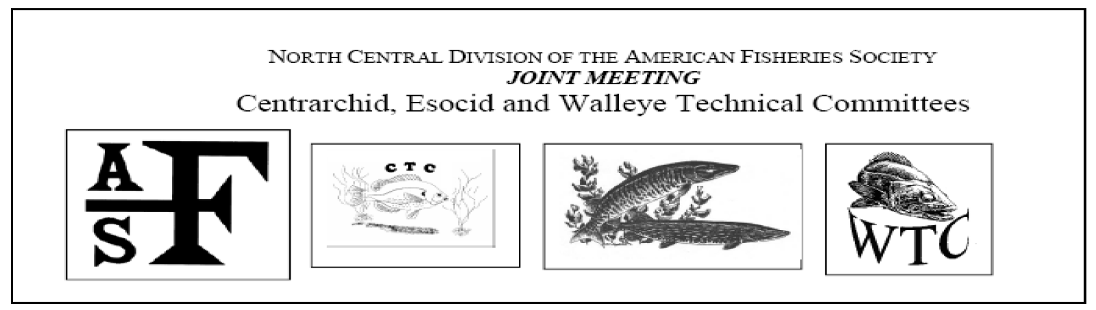
Walleye Technical Committee
Chair: Jeff Koch, jeff.koch@ks.gov
Chair Elect 2017: Dale E. Logsdon, Dale.Logsdon@state.mn.us
Past Chair: John Bruner, jbruner@ualberta.ca
Secretary: Hilary Meyer, Hilary.Meyer@state.sd.us
Web site: http://ncd.fisheries.org/walleye/
“The purpose of the Walleye Technical Committee of the North Central Division of the American Fisheries Society is to promote the research and development of functional management strategies leading to the wise use of native and introduced stocks of walleye, sauger and their hybrids, to improve culture techniques, and to facilitate the dissemination of pertinent data and technology to both the scientific and user communities.”

Esocid Technical Committee
2017 Chair Elect: Janice Kerns janice.kerns@dnr.state.oh.us
Past Chair: Cory Kovacs kovacsc@michigan.gov

Centrarchid Technical Committee
Chair: Dan Dembkowski; Wisconsin Cooperative Fishery Research Unit, dan.dembkowski@uwsp.edu
Proxy: Dan Nelson; Dakota Chapter Representative dtnelson1028@yahoo.com

MINUTES:
2:30-4:30 pm, Hawthorne room, Lincoln Marriott Cornhusker Hotel, Lincoln, Nebraska
Call to Order: Sunday, February 5, 2017 Joint Winter Business Meeting of the CTC, ETC, and WTC. In attendance were: CTC: Sandy Clark-Kolaks (NCD President), Daniel Nelson; ETC: Keith Koupal, Cory Kovacs, Jonathan Meerbeek, Matthew Perrion, Jordan Weeks; WTC: Andrew P. Bade, Brian Blackwell (& ETC rep.), John C. Bruner, Joe Conroy, Jason DeBoer, Steve Gilbert, Nick Kludt, Jeff Koch (& ETC rep.), Dave Luechesi, Brett Miller, Brian Petersen, Casey Schoenebeck, Justin VanDeHey, Melissa Wuellner (NCD Past President).
1. A.) WTC Approval of winter agenda & summer meeting minutes. (see Webpage). Motion Steve Gilbert, Jason Deboer seconded. Approved.
1. B.) ETC Approval of Summer Business Meeting minutes (see ETC Webpage). Motion Jordan Weeks, Jonathan Meerbeek seconded. Approved.
1. C.) CTC Approval of summer business meeting minutes. Approved.

2. A.) ETC Installment of Chair Elect 2017 Janice Kerns. Last minute travel restrictions prevented Janice from attending. Cory Kovacs gave her biography and qualifications to chair the ETC.
2. B.) WTC welcome by past chair, John Clay Bruner and introduction of 2017 chair, Jeff Koch, Kansas Department of Wildlife, Parks and Tourism, 1830 Merchant, Emporia, Kansas 66801, 620-459-6922, jeff.koch@ks.gov

3. A.) WTC Treasurer’s Report: Tony Barada, NCD AFS Secretary-Treasurer
12/12/2016
2016 WTC | Description | Expenses | Deposits | Balance
1-Jan |  |  |  | $12,771.59
24-Jan | Sander award | $100.00
2-Aug | Summer meeting | $2,471.18 | $2,740.00
 |  | $2,571.18 | $2,740.00 | $12,940.41

3. B.) ETC Budget ETC Budget update (1/5/17) provided by Tony Barada, NCD-AFS Treasurer and Secretary
2016 Esocid | Description | Expenses | Deposits | Balance
1-Jan |  |  |  | $3,020.28
9-Mar | plaque | $25.00
29-Mar | book sales |  | $30.00
2-Aug | summer meeting |  | $2,000.00
 |  | $25.00 | $2,030.00 | $5,025.28

3. C.) CTC Financial Report (provided by Tony Barada, NCD Secretary/Treasurer
 |  | $600.00 | $0.00 | $1,032.19
2016 CTC | Description | Expenses | Deposits | Balance
1-Jan |  |  |  | $1,632.19
7-Nov | CTC travel award | *$600.00
 |  | *$600.00 | $0.00 | $1,032.19
*The CTC sponsored a symposium during the 2016 Annual Meeting in Kansas City entitled, “Managing Centrarchids in Rivers and Streams” and provided funds to support a student travel award to the meeting/symposium. The award recipient was Jonathan Watson, a M.S. student at the University of Maine. Jonathan presented a paper entitled, “Studying interactions between smallmouth bass and river herring in the Penobscot River, Maine.

4.) WTC 9th Annual Sander Travel Award to Andrew P. Bade, M.Sc. student in the Department of Evolution, Ecology, and Organismal Biology at The Ohio State University. Andrew is presenting a poster at the Trade Show & Poster Social, Tuesday February 7, 2017 6:00 pm - 9:00 pm, Cornhusker Hotel, Lancaster Ballroom entitled, “Use of Lake Erie's Ohio reef complex by walleye (Sander vitreus) during the spring spawning season”, with co-authors Tom Binder, Christopher Vandergoot, and Matt Faust. $100 check presented by Jeff Koch, 2017 Chair. A $100 check matching the WTC award was presented by the AFS Ohio Chapter representative, Joseph Conroy, joseph.conroy@dnr.state.oh.us

5.) WTC, CTC, & ETC: Invitation to 2017 to the Joint Summer Meeting: Chair of the WTC, Jeff Koch gave a short powerpoint presentation inviting members of the CTC, ETC, and WTC to the summer meeting July 18-20, 2017 at McQuoid's Inn and Event Center, Isle, Minnesota. Organizer for the meeting is Chair Elect WTC, Dale Logsdon, Fisheries Research Biologist, Minnesota Dept. of Natural Resources, 50317 Fish Hatchery Road, Waterville, MN 56096, (507) 362-4223 ext. 228, for more information please contact Dale Logsdon Email: dale.logsdon@state.mn.us

6.) WTC: Hilary Meyer, secretary of the WTC, reports the WTC email distribution list now has 274 names, an increase of 28 names from a year ago. Brian Borkholder, NCD webmaster, reports that the WTC website was the third most visited NCD website for 2016.
News 1387 Views
Pres Blog 896
WTC 546
F/T Jobs 457
Newsletters 305
NCD Jobs 285
ETC 240

7.) New Business:

7. A.) WTC: Increase of WTC’s Sander Travel Award to $200 for 2018.
Background: Nine have been given out since 2007 to eight people.
Purpose: To financially assist a student conducting research of interest to the Walleye Technical Committee (WTC).
Description: A travel grant of $100 from the WTC of the North Central Division of the American Fisheries Society for a student to attend the Midwest Fish and Wildlife Conference.
Eligibility Criteria: The recipient of this award must be a student who is currently enrolled in a college or university for a degree program. Preference will be given to those involved in research of interest to the WTC.
Documentation required: An application letter from the student that includes: student’s name, address, telephone number, educational institution, department, degree level, a short description of current research, reasons for wishing to attend the meeting (paper or poster presentation, pertinent paper session, sub-unit business and/or technical meetings), and reasons why financial assistance is needed.
Selection Criteria: The Operations Subcommittee of the WTC will evaluate applicants based on the following criteria:
a. AFS involvement (reasons for attending the meeting).
b. Relevance of research to the goals of the WTC.
Frequency of Award: The WTC will select one recipient each year.
It is hoped that the increase will lead to more competition for the award and higher attendance of the WTC winter business meeting, and more walleye presentations to the conference.

7. B. i.) ETC: Certificate of Appreciation to Past-Chair Cory Kovacs by ETC member, Jonathan Meerbeek.
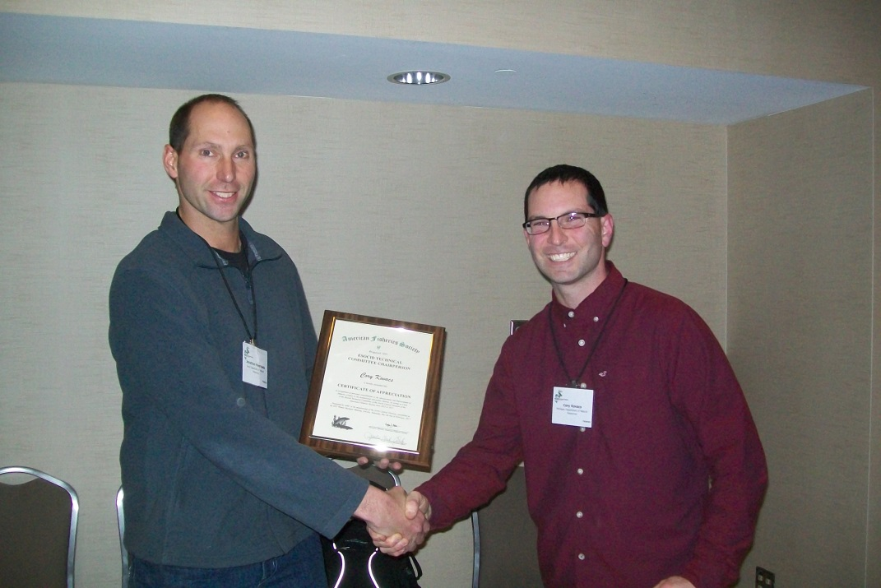

7. B. ii.) WTC: Certificate of appreciation to Past-Chair John Bruner presented by Chair Jeff Koch.

7. C.) ETC: Muskie Telemetry Research Update Janice Kerns (cancelled).

7. D.) ETC: ETC By-laws update. Cory Kovacs said he has a few edits to make, the ETC history needs to be updated, the selection process of officers needs to be improved and approved. Cory will work with Janice on finalizing and said the final document will be sent out to all ETC members to be voted on for approval.

8. E.) Break out session for WTC, ETC & CTC State and Provincial Reports:

8. E. i.) WTC: The following submitted written reports are posted on the WTC website:
Canada: Alberta, Manitoba, Ontario, Québec, Saskatchewan; U.S.A.: Arkansas, Idaho, Illinois, Indiana, Iowa, Kansas, Michigan, Minnesota, Missouri, Nebraska, New York, Ohio, Oregon, Pennsylvania, South Dakota, Texas, Utah, West Virginia, Wyoming.
Seth Herbst put in a plea for help in Michigan’s report , “Insight requested from the group: The Michigan DNR is looking to move away from using large quantities of copper sulfate during the spring fingerling harvest. The MDNR is requesting suggestions of alternatives that don’t include chemical use to effective harvest walleye ponds. Please provide suggestions to Seth Herbst (Herbsts1@michigan.gov).” Several methods were discussed. Steve Gilbert said it is easier to use hatcheries than burrow ponds which are not easy to drain. He said Wisconsin fertilizes the ponds with alfalfa, then introduce zooplankton from sewage ponds, and then harvest the fingerlings 38 days later. Paul Christel, Past Chair of the WTC for 2012, from Northern Wisconsin, suggested (later during the conference, on Monday, February 6, 2017) that if you run a hose and pump water into the ponds the walleye fingerlings thinks it is an outlet stream and swim towards the hose.

8. E. ii.) WTC: Steve Gilbert gave a verbal report for Wisconsin on the status of the walleye fisheries. Fingerlings: 50,000 fingerlings were released in southern Wisconsin where their release seems to be working better. Northern Wisconsin waters are not really benefitting from the release of the increased size of fingerlings. 300,000 fingerlings went to meet existing quotas for northern Wisconsin. Regulations: New rules were passed for Wisconsin’s regulations. A statewide trolling rules was passed but there are different rules county by county because of sunset rules. Staff Issues: There are now 5 fish supervisors for Wisconsin’s DNR. 5 Fishery biologists were hired. 4 of 5 fish technician jobs were filled.

8. E. iii.) ETC: State Updates Summaries are provided from States and Provinces at Winter Business Meeting only; Complete summary of state reports will be completed and included with the minutes following the meeting. Matthew Perrion talked about the growth rates of Nebraska muskies. For all state and provincial updates see attached sheet.

8. E. iv.) Dan Nelson, Dakota Chapter representative led the discussion of brief updates on centrarchid-related research/management/conservation

9. Old Business:

9. A.) ETC: Esocid(s) Symposia for 2020 AFS Meeting-Columbus, Ohio. Cory Kovacs suggested that the ETC will probably present two symposia at the 2020 annual meeting. ETC not interested in a new book as the Muskie Symposium book should be completed in either 2018 or 2019.

9. B.) WTC: John Bruner said the WTC should organize a walleye/sauger symposium at the AFS 150th Anniversary, August 30-September 3, 2020, in Columbus, Ohio in order to highlight the WTC and promote interest. He pointed out that at the Seattle meeting in 2011, Bruner and Bruce Barton organized a very successful 1.5 day long walleye symposium based mostly on the AFS walleye book. Bruner said the 2020 symposium papers should be published in a new AFS walleye book. Another possibility would be a dedicated issue of the AFS Journal of Fisheries Management.

A motion to adjourn the joint meeting was made by Jordan Weeks and seconded by Justin VanDeHey. Motion was carried and the meeting adjourned at 4:08 pm.

Respectfully submitted,
John Clay Bruner, Past Chair, Walleye Technical Committee and Jeff Koch, Chair of the Walleye Technical Committee.

