**State and Provincial Reports on Walleye/Sauger Fisheries**

**1.) Alberta, Canada**

Attached are 3 documents describing the current status of walleye in Alberta. We’ve developed a cool ranking system, the Fish Sustainability Index, as a “report card” for our fisheries. In very brief, if the abundance and size structure of a walleye population are skookum, it gets a high score (4 or 5). If it is collapsed, it gets a 1 or 2. We use FWIN-style test netting to determine abundance and population  structure (= age and size distribution).

The results of the latest (2015) walleye ranking is in the “external content” document. The overview and technical details are in the other two documents. And a photo of me with a walleye, so folks can remember who I am.

**See:** ALBTA. Walleye FSI external content MGS Dec 2015

**See:** ALBERTA Walleye Fish Sustainability Index 2013 Assumptions and Thresholds

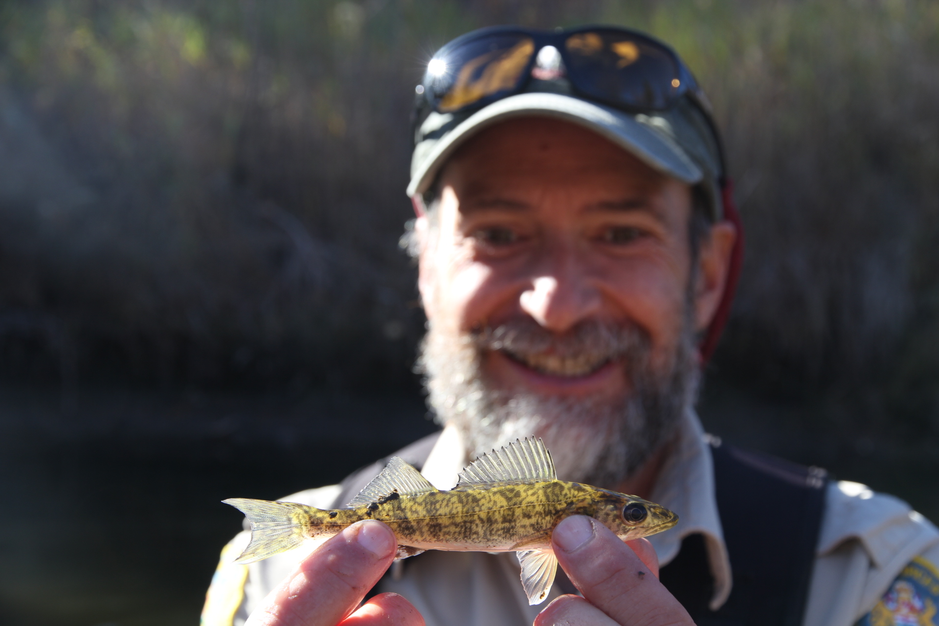

Dr. Michael G. Sullivan

Fisheries Scientist

Fish and Wildlife Policy Branch

Environment and Parks

Alberta NDP Government

O.S. Longman Bldg.

6909-116 St.

Edmonton, AB

T6H 4P2

[michael.g.sullivan@gov.ab.ca](mailto:michael.g.sullivan@aemera.org)

**2.) Ontario, Canada**

Attached is a portion of the 2015 *State of Ontario’s Biodiversity Report* that deals with walleye.  Al Dextrase was MNRF’s lead for this report; if you have any questions, please direct them to him.

**See:** Ont. Indicator-Walleye-Harvest-in-Inland-Lakes_May-19-2015

**See:** Ontario 2014 Management

**See:** Ontario 2015 Indicator-Walleye-Harvest-in-Inland-Lakes_May-19-2015

**Steven M. Bobrowicz**

Regional Fisheries Specialist

Ontario Ministry of Natural Resources and Forestry

Northwest Region Planning Unit

435 James St. S

Suite 221A

Thunder Bay, ON  P7E 6S8

[(807) 475-1536](tel:%28807%29%20475-1536)

**3.) Manitoba Central Region Walleye Update 2015.**

Lake Winnipeg, Manitoba’s largest lake at 2,438,700 hectares continues to deliver high commercial yields of Walleye, though less than the peak years between 2005 and 2013 when commercial yields were 4,500,000 kg per year. In 2014 the commercial Walleye harvest was 3,500,000 and the 2015 yield is expected to be less than 3,000,000 kilograms. The decline coincides with total annual mortality estimates creeping up to 49%. The total annual mortality rate that generates the maximum sustainable yield is 39%. The Lake Winnipeg Sauger stock is growing. The total annual mortality rate for Lake Winnipeg Sauger is 48%, whereas the total annual mortality rate at MSY is 55%. Despite a new roe market incentivizing the commercial harvest of large female Walleye, total annual mortality of an exceptional 2001 year class of is low at 24%, and these fish now mostly between 2.5 and 4 kg continue to attract large numbers of fall and winter anglers. The spring general closure of southern lakes in Manitoba that used to begin April 1st in the middle of school spring break has been postponed a few days until the children return to school in order to provide more angling opportunity during the break. Zebra mussels were discovered in the south basin of Lake Winnipeg in the fall of 2013 and densities are increasing rapidly.

Lake Manitoba is Manitoba’s third largest lake at 462,400 hectares. Lake Manitoba’s Sauger stock remains in a collapsed state. The commercial harvest of Sauger historically was in excess of 100,000 kg annually. Less than 1000 kg were delivered in the 2014/15 fishing year. Commercial Walleye deliveries remain at about 1/3 of potential. In the 2014/15 fishing year only 124,000 kg of Walleye were delivered by commercial fishers. Total annual mortality of Walleye in Lake Manitoba is 55%. The total annual mortality at MSY is estimated to be 41%.

Waterhen Lake, a smaller 25,000 hectare lake that bears the distinction of becoming the second commercial freshwater fishery in the world to achieve Marine Stewardship Council sustainable fishing certification, passed its first annual audit by MSC, and the Walleye have been discovered by a niche market willing to pay a higher price for the sustainably sourced Walleye. Total annual mortality was estimated at 35%, below AMSY.

Eastern Region has mostly smaller recreational lakes and Derek Kroeker (for Ken Kansas) sent the following:

As far as Walleye fisheries in the Eastern Region the following statement could be made:

“Many of the Walleye fisheries in the Eastern Region have stabilized due to the slot limit (45-70cm) in the majority of the popular fisheries. A reduction in the daily creel limit from 6 to 4 Walleye in some of the nutrient-poor Canadian Shield Lakes has further contributed to stable Walleye fisheries.”

**Geoff Klein**

Manitoba Regional Fisheries Manager

Manitoba Water Stewartship

PO Box 6000

Gimli, Manitoba

R0C 1B0 Canada

[(204) 642-6099](tel:%28204%29%20642-6099)

[geoff.klein@gov.mb.ca](mailto:geoff.klein@gov.mb.ca)

**4.) Québec, Canada**

Martin Arvisais, Daniel Nadeau, Michel Legault, Henri Fournier, Francis Bouchard, and Yves Paradis wrote the most recent walleye management plan for Québec (2011-2016). Here is a link to the webpage where you can access a pdf of the management plan (in French).

<https://www.mffp.gouv.qc.ca/english/wildlife/hunting-fishing-trapping/walleye-management-plan.jsp>

Québec’s 2011-2016 Walleye Management Plan: a new regulation to know! The regulation on walleye fishing has been amended following the introduction of this Walleye Management Plan. These changes are needed to improve the health of walleye populations and quality of fishing.

By following these regulatory measures, you are helping to preserve this species to the delight of more than 300,000 fishermen like you in Québec.

Emmanuelle Chretien, MSc

CARS Student representative, PhD student

Department of biology, Université de Montréal

Pavillon Marie-Victorin

90 avenue Vincent-d’Indy

Montréal, Québec

H2V 2S9 Canada

[emmanuelle.chretien@umontreal.ca](mailto:emmanuelle.chretien@umontreal.ca)

**5.) Saskatchewan Provincial report on walleye/sauger fisheries**

Saskatchewan is home to hundreds of lakes with walleye and sauger fisheries. These range from reservoirs in the south that are reliant on stocking to maintain populations, to naturally reproducing populations in the clean, clear waters of the Boreal Shield in the north.

**Walleye population assessment and management**

Walleye (and sauger) assessment is done through Ministry of Environment’s (MoE) standardized test netting during the summer. Over the past number of years, Saskatchewan has taken steps to standardize netting procedures based on science and best practices given the resources available. Overall, walleye fisheries in the province are doing well, with good harvests from the recreational and commercial fisheries. Some walleye lakes that have had collapsed walleye populations due to overharvest are showing signs of recovery due to management actions.

Some lakes in the province have special walleye regulations to limit harvest to either recover overfished populations, or support trophy fisheries. Reduced creel limits are typically used, with some lakes having a combination of reduced limits and size restrictions.

Walleye/sauger hybridization has been identified in the province, although it is not well studied. MoE has been working with researchers at the University of Regina to better understand the degree of hybridization and its potential implications on management. Sauger are currently found in three river systems in the province: the Qu’Appelle, the Saskatchewan (North and South), and the Churchill (including Reindeer River).

**Fish stocking and hatchery operations**

Saskatchewan has one fish hatchery located in Fort Qu’Appelle which is responsible for producing the province’s annual demand for walleye. Fertilized eggs are collected from local lakes and incubated in the hatchery to fry stage, at which point they are stocked into lakes and reservoirs around the province. Local fish and game clubs operate a few mini-hatcheries which are supplied as well for local stocking projects. At present, the hatchery does not have the capacity to develop fingerling walleye, although an engineering study has been undertaken to evaluate the facility and consider multiple options one of which may include walleye fingerling production.

In order to minimize demand on the one hatchery, the province has undergone a review of its stocking program to ensure efficiencies. This has included switching from annual stocking to every second or third year stocking to help determine the presence/absence of natural reproduction and lessen annual fry requirements. We are also adjusting stocking rates on select waters to ensure lakes are not over-stocked. Many lakes that have shown evidence of naturalization of stocked walleye, or lakes with naturally reproducing walleye populations have had walleye stocking discontinued.

Given the north-south gradient of our stocked walleye waters, concern has been expressed about the timing of the stocking in northern most lakes compared to temperature and forage base availability. To address this, the province is planning on further field work this summer to assess the suitability of the receiving lakes compared to when walleye fry are stocked in hopes to maximize survival.

**Mark Duffy**

Fisheries Biologist  Ministry of Environment

1328 La Ronge Avenue

 La Ronge Saskatchewan

S0J 1L0 CANADA

[(306) 425-4247](tel:%28306%29%20425-4247)

mark.duffy@gov.sk.ca

**6.) Idaho Walleye**

Walleye were first introduced in Idaho waters in the mid 1970’s with the intent of providing new and diverse fishing opportunities. Three Walleye fisheries were established by the Idaho Department of Fish and Game (IDFG) in isolated reservoirs in southern and southeastern Idaho. Due to the potential impacts of walleye on native fishes and or other existing fisheries, these locations were carefully selected for their isolation with the intent confining walleye to only desired waters. However, illegal or unintentional (e.g. downstream drift from illegal introductions in adjoining states) introduction of walleye has occurred in at least five other waters throughout the state.

Walleye are classified as a game fish in Idaho. A harvest limit of six fish with no size restriction is used to manage two of the three intentional walleye fisheries. Recently, a six fish only one over 20 inch regulation was enacted on the third fishery. This regulation change was requested by anglers to improve abundance of large walleye. Idaho does not support walleye where unauthorized introductions have occurred. As such, all other waters where walleye may occur are managed with no harvest limit and no size restriction. In addition, Idaho does not authorize catch and release walleye tournaments on waters where unauthorized walleye introductions have occurred. Walleye exploitation in existing fisheries is generally thought to be low. Annual exploitation, where estimated, was 10% or lower.

Densities of walleye in our three intended walleye fisheries are considered moderate to high with fall walleye index netting (FWIN) average catch rates as high as 37 walleye per net. Idaho has no statewide standard for monitoring walleye, but FWIN protocol, established in Ontario Canada, have been used to survey two of the three intentional walleye waters as well as two of the unintentional walleye waters. Densities in unintended walleye waters have been low thus far and range from “occasionally found” to FWIN catch rates of 2 fish per net or less.

To date, no true “suppression” effort has been completed to reduce or eliminate walleye where they are unintended. Although walleye are not desired in most waters in Idaho, challenges associated with eliminating walleye have prevented suppression efforts. These challenges include: large, complex, and connected water bodies; diverse multispecies fish communities (some with sensitive native fish); and financial limitations.

The reports attached have FWIN survey results from two of our unintended walleye waters. I know recent work on at least one of intended walleye waters has been completed, but I was unable to get a report on that work at this time.  We do have past reporting on FWIN surveys from two of the intended walleye waters if you’re interested.

**Attached Reports:**

**Also See: IDAHO LPO FWIN**

**Also See: IDAHO MGT2013 Region 6 Uppersnake Annual Report**

**Rob Ryan**

Idaho Department of Fish and Game

11105 N Maple St

Hayden, ID 83835

[(208) 769-1414](tel:%28208%29%20769-1414)

[rob.ryan@idfg.idaho.gov](mailto:rob.ryan@idfg.idaho.gov)

**7.) Illinois**

We have no updates on anything for Illinois’ report.  We sent out many requests for information, but no one had any updates on projects or research, and fall sampling data has not been compiled or analyzed yet.

**Jason A. DeBoer**

Large River Fisheries Ecologist

Illinois River Biological Station

Illinois Natural History Survey

704 N. Schrader Ave

Havana, IL 62644

[(309) 543-6000](tel:%28309%29%20543-6000)

[jadeboer@illinois.edu](mailto:jadeboer@illinois.edu)

**8.) Iowa WTC Report, January 2016**

**We are in the process of updating Iowa’s WAE Management Plan**

**Projects:**

**Walleye stocking strategies in reservoirs.**

**Rebecca Krogman (rebecca.krogman@dnr.iowa.gov)**

* All waters stocked with advanced fingerling walleye were electrofished twice during October-November 2015, once before fingerling stocking and once after. A total of 41,800 advanced fingerling Walleye were fin-clipped and stocked into Lake Manawa, Lake Macbride, Lake Icaria, Little River Watershed Lake, Pleasant Creek Lake, and Twelve Mile Lake with the assistance of district fisheries management teams and the Rathbun Fish Hatchery.
* Age structures (dorsal spines) from 2014 and 2015 were prepared for reading. Out of approximately 1,500 Walleye dorsal spines, one-quarter are cast and require sectioning and three-quarters are sectioned. All spines still need to be aged.

**Evaluation of interior river fingerling walleye stocking strategies.**

**Greg Gelwicks ((greg.gelwicks@dnr.iowa.gov)**

* Brand retention was assessed on intensively and extensively reared walleye fingerlings that were branded in spring and held at Rathbun Hatchery, then released into interior Iowa rivers.
* Fall electrofishing was conducted at sites on the Cedar, Wapsipinicon, and Maquoketa Rivers to evaluate survival and growth of marked intensively and extensively reared fingerlings that were stocked in the spring.

**Population dynamics of adult Walleyes in Iowa’s large natural lakes.**

**Jonathan Meerbeek (jonathan.meerbeek@dnr.iowa.gov)**

* Conducted 39 5-10-min trawl hauls on Spirit Lake and East Okoboji Lake to sample walleye and other fish communities so that a multi-metric year class index could be established.
* Sampled Walleye populations via night electrofishing in Spirit Lake and East Okoboji Lake.
* Sampled YOY walleye in Clear Lake via trawl, seine, and electrofishing.
* Removed, mounted, and viewed age-0 Walleye otoliths via epifluorescent microscopy to determine OTC mark presence or absence and provided managers with update on near-shore vs. off-shore fry stocking results.
* Prepared and disseminated monthly creel reports.
* Conducted 20 5-min trawl hauls on Clear Lake.

**Evaluation of Therapeutants and Methods to Manage Cool and Warmwater Fish**

**Diseases. Alan Johnson (alan.johnson@dnr.iowa.gov)**

Objectives:

* Conduct pivotal field efficacy trials on diseases and therapeutants for cool (walleye) and warmwater fish
* Evaluate *Ichthyopthirius multifilis* disease management and treatment at Rathbun Fish Hatcheries

**Intensive culture of walleye fry and fingerlings fed formulated diets and reared to a minimum of 200 mm. Alan Johnson (alan.johnson@dnr.iowa.gov)**

Objectives:

* Evaluate the survival, growth, and deformity rate of extensively reared walleye during training on formulated feed and follow up grow-out at Rathbun and Spirit Lake Fish Hatcheries
* Evaluate the survival, growth, and deformity rate of intensively reared walleye fry trained on formulated feed from day 1 post-hatch through grow-out at Rathbun Fish Hatchery and Rathbun Fish Culture Research Facility
* Evaluate recycle aquaculture systems technologies for walleye fingerling production

**PIT tag assessment Mark Flammang (mark.flammang@dnr.iowa.gov)**

* PIT tags (Passive Integrated Transponder tags) have commonly been utilized in both Walleye and Muskellunge and recent investigations suggest their cost-effectiveness is improving. PIT tag retention is believed to be high with musculature implantations; however, issues with potential angler ingestion of captured fish are problematic from a liability perspective. In this study, we evaluated differential tag retention and mortality of 10-13” Muskellunge and 7 to 10 inch Walleye implanted with 12 mm, 23 mm, and 32 MM HDX PIT tags. Six treatments for each species were evaluated. All three tag sizes were placed either in the dorsal musculature or interperitonealy. In addition, a separate control group was handled similarly. Thirty fish were subjected to each trial and given a unique combination of fin clips. Fish were held from December 2014 until April, 2015 in an indoor raceway at the Rathbun Fish Hatchery. No post tagging mortality of Muskellunge was observed through the duration of the study. Tag retention of interperitonealy tagged fish was poor, averaging just 40% across all three tag sizes. In most cases, tags were expelled within the first two weeks following implantation. Walleye retention was excellent and no lost tags were observed. However, mortality for interperitonealy tagged fish was high, especially for 23 mm and 32 mm tag sizes. Approximately 40% of these fish perished following implantation. Necropsies of these fish showed that several fish had tags injected into the swim bladder and all had poorly healed wounds at the implantation site.

**Factors affecting mercury concentration in Iowa fishes. Darcy Cashatt (darcy.cashatt@dnr.iowa.gov)**

Objectives:

* Evaluate mercury concentration sport fishes from a complete range of lengths and wide range of ages from at least 25 public lakes and 6 rivers and streams



|  |
| --- |
| **Figure 1**. The range of mean mercury concentration found in fish fillets and plugs of 21 species sampled from Iowa lakes, large rivers and streams from 1994 through 2011. ND = not detected. The detection limit is 0.018 mg/Kg |

Recent Iowa publications:

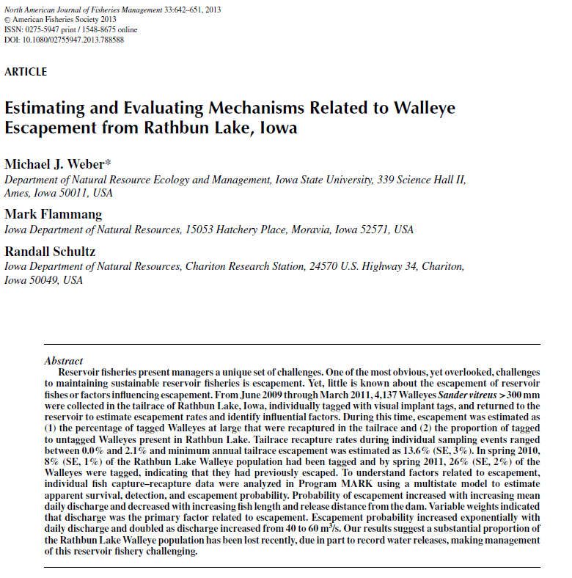

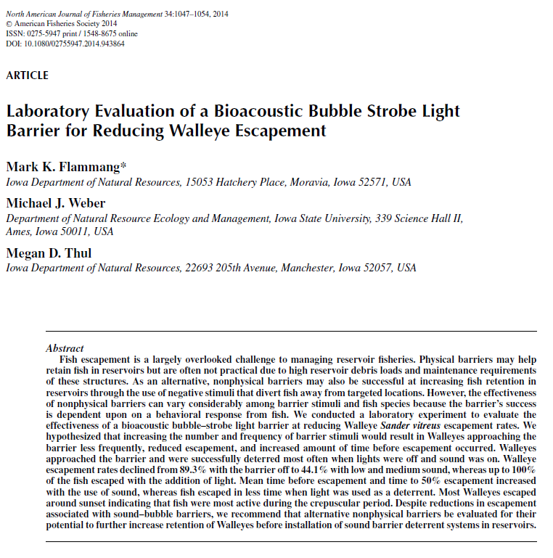

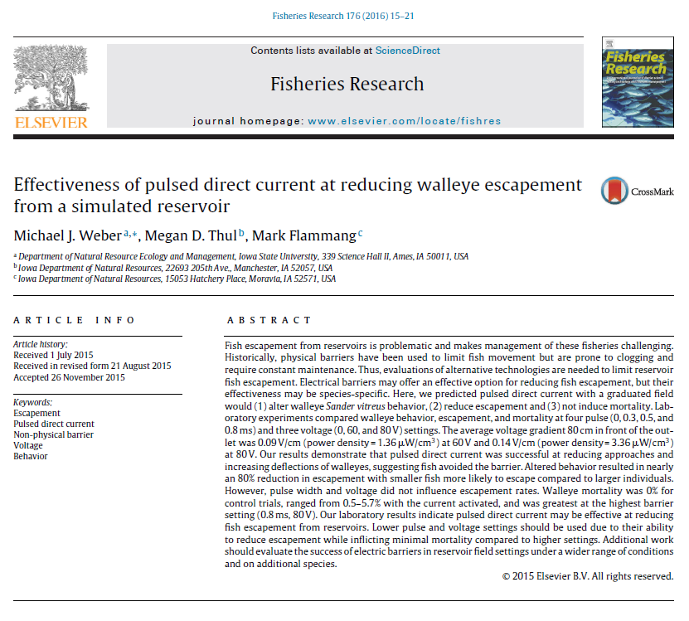

**Randall Schultz, Ph.D.**

Supervisor, Mississippi River Resource Management

Iowa Department of Natural Resources

110 Lake Darling Road

Brighton, Iowa

52540 USA

319-694-2430

[Randy.Schultz@dnr.iowa.gov](mailto:Randy.Schultz@dnr.iowa.gov)

**9.) Kansas, Kansas Department of Wildlife, Parks and Tourism**

The percid egg demand in Kansas is slightly increasing in recent years. In 2015, 85M walleye eggs, 7M saugeye eggs, and 4M sauger eggs were collected from brood reservoirs.

Milford Reservoir was the site of the 2015 NTC tournament sponsored by Cabelas. A total of 185 teams participated and the winning three-day bag was 10 fish weighing 43 lb. Public pressure from local anglers and agency personnel led to an evaluation of the tournament by angler diary (prefishing and tournament diary) and concurrent exploitation study. Participation in the angler diary was poor, with only about 10% of anglers participating, and the data acquired was poor as well. A follow-up online survey was sent to all tourney anglers, but only ~15% of anglers responded. Take home messages were that anglers did not like wipers and blue catfish, generally did not report tagged fish, and did not harvest fish. Current exploitation rates suggest about 45% annual exploitation with the vast majority of catch and harvest occurring in April, May, and June.

Kansas is experimenting with protocols to produce fingerlings and advanced fingerling walleye in tank culture. The pilot project was met with some success. Stocking large fingerlings may be attempted in reservoirs with high densities of nuisance white perch where getting walleye recruitment is difficult.

Kansas may be implementing more restrictive regulations in attempt to provide high-quality walleye fisheries and reduce the likelihood of overfishing, as Mike Quist’s work suggested. Restrictive seasonal length limits (i.e., 24” MLL), are being discussed in some large reservoirs.

Kansas continues to stock saugeye in small impoundments and reservoirs with marginal walleye habitat. Triploid saugeye have been produced the last several years, and an evaluation is being conducted to assess growth and survival of triploids and diploids. After two years of stocking and evaluation, diploid saugeye had about three times higher survival than triploids. Additionally, diploid individuals were generally larger than triploids.

Human dimensions work regarding angler perception of walleye management in Kansas was conducted in the last Kansas licensed angler survey. In general, most anglers preferred a moderate minimum length limit over liberal and restrictive regulations. Most anglers did not prefer restrictive regulations; however, anglers that fished waters with restrictive regulations were generally supportive of them after observing effects on populations.

A recently conducted graduate study at Fort Hays State University regarding food habits and biological control of invasive white perch via piscivores indicated that walleye generally consume white perch at a greater rate than other predators. As such, walleye may be the best management option available for this problem species.

**Jeff Koch**

Kansas Department of Wildlife, Parks and Tourism

1830 Merchant, Emporia, Kansas 66801

620-459-6922

jeff.koch@ksoutdoors.com

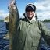

**10.) Minnesota Walleye update to AFS NCD WTC January 2016 By Dale Logsdon**

**Stocking and production:**

2015 stocking:

258,118,150 fry

131,880 small fingerlings

1,276,820 large fingerlings

276,317 yearlings

19,331 > age 1

843 water bodies were stocked with walleyes in 2015.

**Ongoing research projects:**

Paul Venturelli (UofM) - Continued research on use of growing degree-days to describe life history and predict sustainable exploitation rates. Use of Nigel P. Lester’s biphasic growth model to predict age and length at maturity from longitudinal length-at-age data. Fish community changes in Shoal lake, Canada following overexploitation of walleye. Critical spawning habitat in Namakan Lake and how it has been affected by the IJC 2000 rule curve. [*Note:* IJC 2000 rule curve is a ruling by the International Joint Commission regarding water levels on Rainy and Namakan lakes. <http://ijc.org/en_/news?news_id=502> ]

Jake Graham (BSU) - Red Lakes walleye population dynamics (pelican predation in the Tamarac River responsible for <1% total annual walleye mortality, but high mortality of eggs/recently hatched fry occurs due to low DO when the levels get high and spreads out upon the bogs of the flood-plane).

Tyler Ahrenstorff (MNDNR) - Bioenergetics of predator species in Mille Lacs

Tim Cross (MNDNR) - Substrate characterization and spawning habitat in Southern Minnesota.

Dale Logsdon (MNDNR) - Impacts of walleye stocking in lakes with walleye egg take operations (density dependent effects on YOY growth on Woman and Winnibigoshish)

Melissa Treml (MNDNR) – Population modeling on Mille Lacs

Andy Carlson (MNDNR) – Selectivity of experimental gill nets

Jeff Redd (MNDNR) – Evaluation of fryling (small fingerling) stocking in Minnesota

David Staples (MNDNR) – Standardization of a year-class strength index for Minnesota’s large walleye lakes. Effect of changes in angler pressure on the success of slot limits.

**Large Lakes:**

After the unprecedented closure of the walleye fishery in Mille Lacs this summer, the walleye sport fishery was reopened beginning Dec. 1 where anglers can keep only one walleye between 18 and 20 inches, or one longer than 28 inches. Evaluation efforts will be continued so as to help better understand the reasons behind the poor recruitment of walleyes to the fishery. This will include a more thorough evaluation of natural reproduction through the use of an experimental stocking of OTC marked fry.

**Statewide:**

Current statewide initiatives of the DNR include an evaluation or our stocking guidelines and our regulation “toolbox” (suite of walleye regulations available for managers to use on individual waters).

**Dale Logsdon**

Minnesota Department of Natural Resources

50317 Fish Hatchery Rd.

Waterville, Minnesota

56096 USA

(507) 362-4223

[Dale.Logsdon@state.mn.us](mailto:Dale.Logsdon@state.mn.us)

**11.) MONTANA, Montana Fish, Wildlife & Parks**

I was forwarded the e-mail about the AFS NCD WTC being interested in a status report from Montana regarding walleye/sauger waters.  Well, rather than sending you multiple annual reports I thought I’d offer up a data set we’ve been compiling for quite some time.  Attached is an extensive table structured report from nine walleye reservoirs in Montana.  Montana Fish, Wildlife and Parks is currently working on the very document you are requesting and could have it available in the near future, but the attached tables are likely the best we have at the present time.  Please let me know if they will be of use or if you’d prefer to wait for the more verbose version. The attached data is current through 2014.

**See attached file:** **Montana-Walleye Waters_Tables_2014**

**Adam Strainer**

R4 Fisheries

Montana Fish, Wildlife & Parks

Helena Area Resource Office

930 W. Custer Ave.

Helena, MT 59620

[(406) 495-3263](tel:%28406%29%20495-3263)

**12.) Michigan Report for 2016 Winter WTC Meeting**

1) Walleye populations in Saginaw have fully recovered, but during this time Yellow Perch populations have experienced significant declines. Management actions have been put in place to account for this imbalance between predator and prey populations. These management efforts consisted of a liberalization of Walleye regulations and more conservative measures to reduce Yellow Perch mortality. These efforts were informed by new modeling efforts, including a Statistical Catch-at-Age (SCAA) model and a decision analysis, which were developed by David Fielder (MDNR-Alpena Fisheries Research Station) and members of the Quantitative Fisheries Center at Michigan State University. The plan is to use this model and decision framework in the future to determine annual recreational Walleye regulations that will be linked to sustainable levels of harvest, similar to what is currently being implemented for Lake Erie Walleye.

2) OTC marking continues to be a tool to evaluate stocking success, and is mandatory for stocking events in tribal waters. There has been a concern, however, that OTC marked fish are experiencing increased mortality rates. The DNR-Fisheries Division held a meeting and provided background information on the use of marking as an effective stocking evaluation tool, but also discussed the issues of mark quality, detection ability, and increased mortality of OTC marked Walleye. At the conclusion of that meeting future work was discussed and it was deemed necessary that MDNR try to determine the potential factors that might be influencing mortality (e.g., OTC concentrations, D.O., handling, etc.) of marked fish, so this work will likely begin in 2016.

3) Michigan State University, DNR, and Little Traverse Bay Bands of Odawa Indians completed a comprehensive study that examined forage dynamics, movement rates, recruitment, and implications of seasonal movements on harvest allocation in the Inland Waterway (Emmet and Cheboygan counties). Two manuscripts have been accepted for publication and will be available in 2016. The publications are entitled “Estimating walleye (*Sander vitreus*) movement and fishing mortality using state-space models: implications for management of spatially structured populations” and “Walleye foraging ecology in an interconnected chain of lakes influenced by non-native species”. Inquiries about the findings of this study can be directed to Seth Herbst (MDNR), Dan Hayes (MSU), or Brian Roth (MSU).

4) Following concerns of public constituents in the western U.P. regarding our Walleye management actions, Michigan’s Natural Resource Commission requested that a third party review be completed. The third party review was completed by WI-DNR personnel and they provided four major recommendations.

I. Standardize the definition of an adult Walleye when calculating population densities to include all sexually mature fish.

II. Review the benchmarks you use to evaluate Walleye recruitment.

III. Consider revisions of tools used to determine contribution of stocking to adult populations.

IV. Standardize the data used to make determination of the necessity and appropriateness of stocking.

This review provided useful information in an unbiased manner and MDNR’s internal Walleye Committee is determining how to incorporate these into management strategies that will be created during the development of a new Michigan Walleye management plan. The new management plan will be drafted in 2016.

5) Stocking update: During 2015 there were three Walleye brood stock sources used. They included fish from the Muskegon River, St. Marys River, and Bay de Noc. Historically Walleye from the Tittabawassee River were used as a brood stock source, but following VHSv concerns in the mid-to-late 2000s that egg take operation was discontinued. In 2015, ~4.9 million spring fingerlings and ~32,000 fall fingerlings were stocked into public waters across the state.

6) In 2015, a study that evaluated the contribution of hatchery walleyes to stocks in Big and Little bays de Noc was completed. This work was published in the North American Journal of Aquaculture. For more details the manuscript and a shorter summary are provided as attachments. The findings of the study demonstrated that stocked walleyes were detectable in both bays at age-0, and in Little Bay de Noc, they likely persisted to contribute to the sport fishery. The fate of walleyes stock in Big Bay de Noc (BBDN) was less clear, and their contribution to the BBDN walleye fishery was uncertain. Inquiries regarding the study should be directed to Troy Zorn, Michigan DNR-Marquette Fisheries Research Station.

**See attached:** Michigan-1-OTC study summary- 2014

**See attached:** Zorn 2015- Walleye OTC- NAJA

**Seth J. Herbst, Ph.D.**

Fisheries Biologist - Aquatic Invasive Species Coordinator

MDNR-Fisheries Division

525 W. Allegan St.

Lansing, Michigan

48933-1502 USA

Office: [517-284-5841](tel:517-284-5841)

Email: [Herbsts1@michigan.gov](mailto:Herbsts1@michigan.gov)

**13.) Missouri**

See the July 2015 WTC report. There is nothing to add.

**Paul Cieslewicz**

Fisheries Management Biologist, Missouri Department of Conservation

2302 County Park Drive

Cape Girardeau, Missouri

63701 USA

(573) 290-5730

***email:* Paul.Cieslewicz@mdc.mo.gov**

**14.)** **New York**

**State and Provincial Reports on Walleye/Sauger Fisheries – New York**

**Sauger Management**

Sauger are one of the most critically imperiled fish species in New York State and a Conservation Management Plan was recently adopted to aid its recovery. The goal of the plan is to establish and maintain self-sustaining Sauger populations in all suitable waters of native watersheds, including the Allegheny River, Lake Erie, Lake Ontario, and Lake Champlain watersheds.

Recovery actions began in the Allegheny River watershed in 2014, with the development and implementation of a stocking program. In the springs of 2014 and 2015, Sauger fry from Ohio River brood stock were obtained from the West Virginia Division of Natural Resources. Fry were raised at the Chautauqua Hatchery in ponds and stocked in the upper Allegheny Reservoir in early June at about 1.5 inches in length. Electrified trawl and boat electrofishing surveys were conducted in late summer of each year to check the status of stocked fish. A total of 6 young of year Sauger were collected during trawl surveys. Sixty-seven young of year and 17 age 1 Sauger were collected during boat electrofishing surveys. Survey results indicated that stocked Sauger are surviving and growing well and are staying near the area where they were stocked. The prevalence of a variety of fish species in the trawl surveys suggests that the forage base in the upper reservoir is more than adequate to support a Sauger population. Annual late summer surveys in stocked areas will continue for each year Sauger are stocked and a survey will be conducted throughout the watershed in 2020 to determine if the objective of establishing a self-sustaining population was met.

For more information on Sauger management in New York go to: <http://www.dec.ny.gov/outdoor/92788.html>

**Stocking Evaluation of 50 Day Old Walleye Fingerlings**

NYSDEC will continue an evaluation of an experimental Walleye stocking program that was initiated in 2009 using approximately 50 day old, 1.5 inch long, tank raised fingerlings from the Oneida Fish Hatchery. Since the early 1990s, and prior to this program, all the fingerling Walleye at Oneida Hatchery were raised to an advanced size (4-5 inches) and stocked in late summer. Post-stocking evaluations indicated that these fish rarely outperformed DEC’s pond raised fingerlings, which are stocked in early summer at about 1.5 inches in length. It was also an annual challenge to raise enough advanced fingerlings to meet stocking requests due to often extensive mortalities associated with diet transition from brine shrimp to pellets at about 50 days of age, and from diseases associated with poor water quality through the remainder of the rearing process.

To take advantage of the relatively large number of fish (up to 400,000) on hand at the end of the brine shrimp feeding process in June, a program to stock these fish was initiated. A primary reason why this was not tried before was because of a concern that the stress of handling and transporting the 50-day old Walleye would result in significant mortality, as they tend to be highly sensitive at this stage. However, since the inception of the program these Walleye have been as large as our pond fingerlings and their condition at the time of stocking has been good. Eleven lakes have already been stocked for 5 consecutive years and follow-up surveys indicated mixed results, with documented survival of stocked fish in 4 lakes. Another 13 lakes have been added to the program and these will be annually monitored for stocking success for 5 years, with full Walleye population assessments conducted one or two years after the 5 year stocking periods.

**Lake Erie Walleye Management Plan**

A new lakewide Walleye management plan was recently completed. This plan was the result of a joint effort of the fisheries management community (Michigan, New York, Ohio, Ontario and Pennsylvania) and the diverse sport and commercial stakeholder groups on Lake Erie, plus enormous facilitation and technical assistance provided by MSU’s Quanitative Fisheries Center.  The primary goal of the plan is to ensure the long-term sustainability of the Walleye fishery in Lake Erie. The actionable part of the plan is a new fishing policy used for quota management which will be employed for the next 5 years. This quota system is designed to manage the Walleye population as a common shared resource among the jurisdictions, yet provide the flexibility to accommodate the different jurisdictional uses of the resource. Although NY waters are not in Lake Erie’s Walleye interagency quota zone, we were partners in development of the plan recognizing that Walleye are a highly migratory species in Lake Erie. The plan can be found here: [http://www.glfc.org/lakecom/lec/LEC_docs/position_statements/Walleye_managment_plan.pdf](http://www.glfc.org/lakecom/lec/LEC_docs/position_statements/walleye_managment_plan.pdf)

**Spatial Ecology and Migration of Adult Walleye in the Eastern Basin of Lake Erie**

A study was initiated in the spring of 2015 to track Walleye movements in Lake Erie. Walleye are known to move long distances in the lake and understanding and how these movements relate to fishing effort and harvest is essential to properly manage this complex, valuable, multi-jurisdictional fishery. New York State DEC biologists have begun to deploy acoustic receivers in the eastern basin of Lake Erie to monitor the timing, magnitude, demographics, and spatial extent of the western basin migrants tagged on western basin spawning areas by Ohio DNR. Additionally, acoustic transmitters are being surgically implanted into Walleyes from eastern basin spawning aggregations to estimate spawning site fidelity and movement patterns of individual eastern basin spawning stocks. The relative contribution of eastern basin Walleyes to the mixed-origin fisheries in the eastern basin is being assessed by implanting acoustic tags in Walleye captured in the eastern basin summer fishery. Acoustic receivers have been placed on known spawning areas to monitor summer and fall movement. Existing acoustic lines in the western and central basins will allow detection of the westward movement of Walleye tagged as part of this study.

Preliminary results from the first year of tracking include:

I. Thirteen of 70 tags implanted in 2015 have been returned by anglers or commercial fishermen.

II. Exploitation may be a larger component of mortality than previously thought.

III. Western basin (spawning origin) Walleye are in the eastern basin in all months of the year to some extent.

IV. Eastern basin origin Walleye may migrate west to a larger extent than previously thought.

This study will run through 2019. For additional details on the study go to: <http://data.glos.us/glatos/projects/32>

**Long Term Monitoring of the Oneida Lake Walleye Population**

Oneida Lake, at 50,000 acres, is the largest lake entirely within the borders of New York State and it supports the State’s most popular Walleye fishery. Researchers at the Cornell University Biological Field Station have been studying the lake’s fish populations, with a focus on Walleye, since 1956. It is the longest running warmwater fishery assessment in New York State. The Walleye population is managed via annually stocking 150 million fry, special fishing regulations, cormorant hazing, and intensive monitoring of the population and fishery.

All stages of the Walleye population are annually assessed: as larvae with Miller high-speed samplers; as juveniles in the spring, summer and fall with bottom trawls; and as juveniles, sub-adults and adults with gill nets in the summer, supported with mark-recapture for adult fish (age-4 and older) at regular intervals (currently every 3 years, last conducted 2013). The fishery is assessed through annual access site creel surveys and full boat-roving creel surveys every 5 years.

The estimated adult (age 4 and older) Walleye population abundance was 442,000 in 2014, which was an increase from the 2013 estimate of 360,000. The increase in the adult population is the result of a relatively large 2010 year class recruiting into the fishery. The 2010 year class is the largest year class at age 4 since 1987, and constitutes 36% of the entire adult population. Over the full course of the 57 year data series the adult Walleye population has experienced a significant decrease, but has shown a significant increase since 2000 (Figure 1).

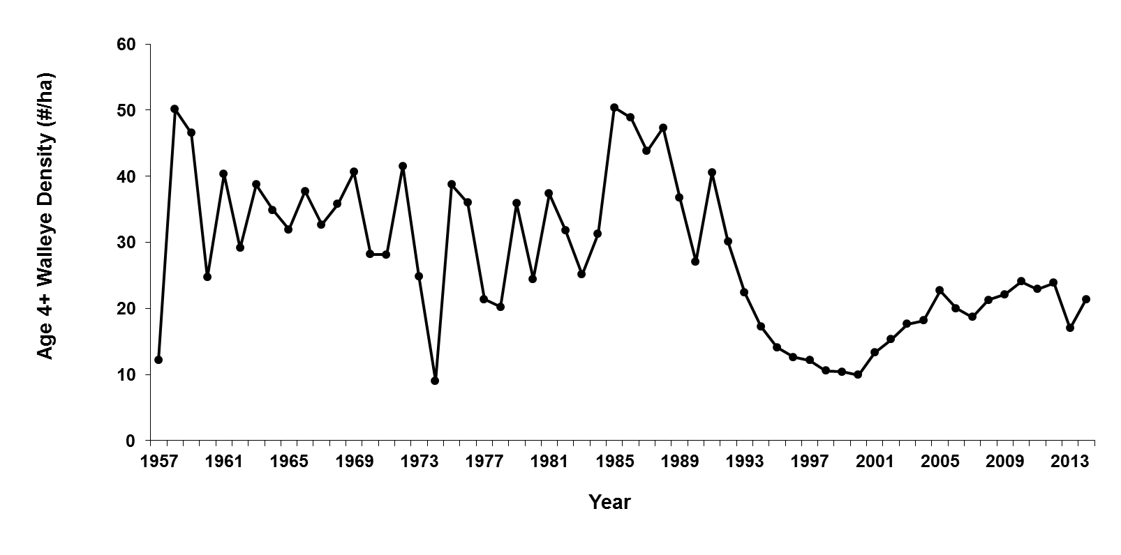

Figure 1. Density of adult Walleye in Oneida Lake, New York, 1957-2014.

In 2014, an access site creel survey was conducted during June and July, which provides an accurate estimate of complete open water season Walleye catch and harvest rates. Estimated fishing effort in 2014 was 217,548 boat hours, which continued a trend of increasing effort since 2002. About 50% of anglers sought Walleye specifically, while 35% sought only bass. The estimated Walleye catch rates for June and July were 0.16/hour and 0.33/hour, respectively (a catch rate exceeding 0.25/hour is characteristic of an excellent fishery). The overall harvest rate was 0.22/hour. The estimated total harvest was 60,192 Walleye, which was slightly more than the estimated total harvest of 58,947 in 2013 and 59,500 in 2012.

For more detailed information on the Oneida Lake Walleye population and other components of the monitoring program go to: <http://www.dec.ny.gov/outdoor/41423.html>

**Contact:**

**Jeff Loukmas**

Warmwater Fisheries Unit Leader, Division of Fish, Wildlife, and Marine Resources

New York State Department of Environmental Conservation

625 Broadway

Albany, New York

12233-4753 USA

*telephone*: (518) 402-8897

*FAX:* (518) 402-8925

*Email:* Jeffrey.Loukmas@dec.ny.gov

[www.dec.ny.gov](http://www.dec.ny.gov/)

**15.) North Dakota**

**State Report for North Dakota at the 2015 Walleye Technical Committee Meeting.**

The walleye population in Devils Lake is doing well. There are many age-classes of walleye in the lake and some of the fish can become quite old, as a 21 year old was sampled in 2013.

We conducted our Standard Adult Sampling on Devils Lake in July. The overall CPUE of walleye fell to 18.2 walleye/net-night in our 125’ variegated gill nets. (24.8 last year) This is the first time since 2005 that the overall catch rate has fallen below the long-term average of 20.5 walleye/net-night. However, the drop in catches were mostly in the substock and stock-quality size ranges, probably due to lower recruitment in the past three years. The catch rates for walleye greater than quality size either fell only slightly or increased slightly. We will resume walleye stocking in Devils Lake in 2016.

The North Dakota Game and Fish Department has continued working with the US Fish and Wildlife Service and local angling groups to open up the Lake Alice National Wildlife Refuge to ice fishing. Ice fishing is now allowed on the roughly 15,000 acre lake that supports walleye, pike, perch and white bass. Anglers have definitely been taking advantage of this new fishing opportunity this winter as our ice fishing season has gotten off to a slower start than normal. The Lake Irvine/Lake Alice complex has had fishable ice for much longer than other areas in the Devils Lake system.

In the Northeast District of the state, some of our most impressive walleye waters continue to be new fisheries that were formerly duck-marsh type habitats. Some of these waters are also able to produce good numbers of walleye over 24” long.

Across the rest of the state, the good old days of walleye fishing continue to be right now. We are still relatively wet and the fish populations have responded very well to the abundance of water. Since 1997 we have added 87 new walleye fisheries. State-wide there are currently 146 waters that have fishable walleye populations and we seem to be able to add a few on to the total each year, as there were 141 last year. About the only place where walleye are not doing so well is the Missouri River system below Lake Sakakawea. This is due to habitat degradation and poor forage production since the flood of 2011. Conditions are improving, but there are still some areas where the walleye populations are still in tough shape.

Our department stocked walleye in 131 lakes in 2015. The 8.5 million fingerlings stocked were generally about 30 days old and were around 1.25” long.

Previous to this year, zebra mussel veligers were sampled periodically in the Red River near the confluence with the Otter Tail River near Wahpeton, ND. However, this year there were large numbers of veligers sampled throughout the North Dakota portion of the Red River. There were also adult zebra mussels discovered at several locations throughout the Red River this fall as well.

**Todd Caspers**

North Dakota Game and Fish Department

7928 45th St. NE

Devils Lake, North Dakota

58301 USA

701-739-6869

[tcaspers@nd.gov](mailto:tcaspers@nd.gov)

**16.) Ohio**

**State of Ohio report to the Walleye Technical Committee**

Prepared by Matthew Faust, Fisheries Biologist II, Sandusky Fisheries Research Unit, Ohio Department of Natural Resources, Division of Wildlife.

**Lake Erie Walleye Population Status**

Ohio serves on the Great Lakes Fishery Commission’s Lake Erie Committee via the Walleye Task Group (WTG). Data for 2015 are currently being analyzed, and so a summary of the 2014 population assessment and fishery statistics are provided. At total of 2.669 million Walleye were harvested across Lake Erie, which included 1.577 million fish harvested by the sport fishery and 1.292 million fish harvested by the Ontario commercial fishery. Sport effort totaled 2.940 million angler hours, and harvest per unit effort was 0.51 Walleye/angler hour. Age-2+ population estimates for Walleye in the western and central basins was 25.125 million fish.

The full WTG report, which contains detailed fishery and population statistics, can be found here: <http://glfc.org/lakecom/lec/WTG_docs/annual_reports/WTG_report_2015.pdf>.

Additional updates regarding ongoing research of note on Lake Erie and Ohio’s inland waters are provided below.

**Lake Erie Walleye Spatial Ecology Study**

In 2010, an inter-lake walleye spatial ecology telemetry study was initiated between the Michigan Department of Natural Resources, Ohio Department of Natural Resources, United States Geological Survey, Carleton University, and Great Lakes Fishery Commission. The objectives of the study are to 1) determine the proportion of walleyes spawning in the Tittabawassee River or in the Maumee River that reside in the Lake Huron main basin population, move into and through the Huron-Erie-Corridor, and reside in Lake Erie, 2) identify the environmental characteristics associated with the timing and extent of walleye movement from riverine spawning grounds into Lake Huron and back again, 3) determine whether walleye demonstrate spawning site fidelity, and 4) compare unbiased estimates of mortality parameters of walleyes from Saginaw Bay and the Maumee River.

A similar spatial ecology study was initiated during the spring of 2013. One hundred sixty-five walleye (n=100 male and 65 female) were collected with gill nets during the spawning period on (males) or in the vicinity of (females) Toussaint Reef. An additional 108 walleye (n = 75 male and 33 female) were tagged in 2014. Each fish was implanted with an acoustic transmitter and had an external reward tag ($100) attached. Captured fish should be reported to the phone number listed on the tags, via the internet by logging onto http://data.glos.us/glatos, or by contacting one of the LEC agencies.

The objectives of this study are to: 1) determine the proportion of walleye originating from two western basin spawning stocks (i.e., Toussaint Reef and Maumee River) that migrate out of the western basin of Lake Erie after spawning, 2) compare spawning site fidelity rates between these two spawning stocks, 3) determine if female walleye from these spawning stocks are annual spawners, and 4) compare total mortality rates (i.e., fishing and natural) for these spawning stocks. This telemetry study is funded by the Great Lakes Fishery Commission, Ohio Department of Natural Resources and the Ontario Ministry of Natural Resources and will be a collaborative effort of the LEC agencies, the United States Geological Survey and Carleton University.

An additional study focused on the effects of a dam removal in the Sandusky River began in 2014. Walleye (n = 101; 48 males and 53 females) were collected via electrofishing during the spawning period and tagged. The objectives of this study to: 1) determine if Sandusky River walleye move upstream of the Ballville Dam once it is removed and hydrologic connectivity is reestablished, 2) determine the spatial distribution of walleye spawning activity in the Sandusky River following dam removal, and 3) to compare survival rates of Sandusky River walleye to other discrete walleye spawning stocks in Lake Erie.

In 2015 a cooperative eastern basin walleye acoustic telemetry study will begin, involving the New York State Department of Environmental Conservation, Ohio Department of Natural Resources, Pennsylvania Fish and Boat Commission, Ontario Ministry of Natural Resources and Forestry, Great Lakes Fishery Commission, and Michigan State University. The broad goal of this work is to address areas of uncertainty that prevent the inclusion of the eastern basin in a multi-jurisdictional assessment. The objectives of this study are to: 1) estimate the annual contribution of western basin walleye to the eastern basin fishery, 2) quantify the 10 timing, magnitude, demographics, and spatial distribution of central and western basin migrants in the eastern basin, 3) estimate and compare spawning site fidelity rates in the eastern basin, 4) describe the movements of eastern basin walleye out of the eastern basin, and 5) estimate total mortality rates (i.e., fishing and natural) for the major spawning stocks in the eastern basin.

Results from these telemetry studies will be forthcoming during the coming years.

**Ohio River Sauger Updates**

Prepared by Jeremy Pritt, Ohio Division of Wildlife, Inland Fisheries Research Unit

Sauger provide a popular fishery throughout Ohio’s 451 mile stretch of the Ohio River and the lower portions of several major tributaries. Angler catch rates of Sauger in the Ohio River can be very high, particularly during the spring, winter, and fall in tailwaters, and Sauger are one of the few species in the Ohio River that are regularly harvested by recreational anglers. In cooperation with neighboring agencies, the Ohio Division of Wildlife has conducted standardized fall electrofishing sampling in Ohio River tailwaters since 2005 to monitor Sauger and Walleye populations. In addition to annual fish sampling, periodic creel surveys have been conducted since the 1980s to determine effort, catch, and harvest of Ohio River Sauger and other sportfish. The most recent creel survey was conducted in 2012 and planning has begun for a river-wide creel survey in 2017.

We are currently using the long-term electrofishing dataset to evaluate spatial and temporal trends in Sauger abundance, growth, and mortality. Total Sauger abundance and age-0 abundance is highly variable among years and generally greater downstream than upstream. Overall, Sauger mortality in the Ohio River appears to be very high, with the highest mortalities occurring in tailwaters with the greatest angling effort. Sauger populations are composed of mostly small (<350 mm) individuals. We plan to use the upcoming 2017 river-wide creel survey to get a better understanding of harvest and exploitation and continued long-term standardized sampling will allow us to determine factors influencing recruitment.

Bryan Kinter

Ohio Division of Wildlife

Email: [bryan.kinter@dnr.state.oh.us](mailto:bryan.kinter@dnr.state.oh.us)

Phone: 419-429-8370

**Using acoustic telemetry to compare walleye and saugeye availability to anglers in an upground reservoir.**

Due to flat topography, most reservoirs in Northwest Ohio are upground reservoirs, which are built above the ground and filled by pumping water from a nearby river. Most of these reservoirs are small and have nearly uniform depth and lack littoral habitat. Saugeye and walleye are two sportfish stocked in Ohio’s upground reservoirs; some reservoirs get saugeye and some get walleye, but none currently get both. If, despite the lack of littoral habitat, saugeye remain closer to shore than walleye in these systems, and thus are more available to shoreline anglers, fishing opportunities for shoreline and boat anglers could be maximized by stocking both into the same reservoir. To explore this, we implanted acoustic transmitters into 15 walleye and 15 saugeye and released them into Findlay Reservoir #1, an upground reservoir outside of Findlay, Ohio. Tagged fish were tracked continuously from April 2013-December 2014 with the Vemco VR2W Positioning System (VPS). Harvested fish or fish that disappeared (likely unreported harvest or transmitter failure) were periodically replaced. In total, 45 fish (27 saugeye; 18 walleye) were tagged for this study and the VPS generated 823,626 useable fish positions.

The proportion of total positions within casting distance (defined as less than 25 meters from shore) was estimated using a Bayesian hierarchical modeling approach, using species (2 levels; saugeye, walleye), season (7 levels; Spring 2013-Autumn 2014), and period of day (3 levels; day, night, crepuscular) as explanatory variables. For saugeye, the proportion within casting distance for the 21 combinations of season and period of day ranged from 0.11-0.71, and for walleye it ranged 0.08-0.64. For 14 of the 21 combinations of season and period of day, saugeye were more likely to be within casting distance (2-4 times as likely), and for the remaining 7, there was no difference between saugeye and walleye. Walleye were never more likely to be within casting distance. The largest differences occurred during summer and autumn.

Movement (in reality, minimum displacement) was also analyzed using a Bayesian approach using the same explanatory variables. Saugeye movement ranged from 62-515 m/h and walleye movement ranged 44-568 m/h. There was very little difference between species, but there was significant variation with season and period of day. For all seasons, walleye and saugeye movement was greatest during either the crepuscular or night period, never during the day. Generally, movement was greatest in the spring and lower in the other seasons, especially winter.

These results indicate that stocking both saugeye and walleye may maximize opportunities for shoreline and boat anglers in upground reservoirs, as saugeye were more frequently within casting distance than walleye.

**Matthew Faust**

Fisheries Biologist

Sandusky Fisheries Research Station

Ohio Department of Natural Resources, Division of Wildlife

305 East Shoreline Drive

Sandusky, Ohio 44870

Phone: [419-625-8062](tel:419-625-8062) ex. 104

Email: [matthew.faust@dnr.state.oh.us](mailto:matthew.faust@dnr.state.oh.us)

**17.) South Dakota**

**South Dakota Percid updates 2015**

Spawning:

During 2015, a total of 75.7 million Walleye eggs were collected from 9 South Dakota Lakes and this resulted in 36.1 million Walleye fry (48% hatch) being stocked into South Dakota lakes or hatchery ponds. Also, 7.1 million Yellow Perch eggs were collected which resulted in 4.5 million eyed eggs being available to either stock hatchery ponds, natural rearing ponds, or use to produced fry. Yellow Perch fry production attempts were unsuccessful during 2015.

New for 2016:

SDGF&P is planning to produce large and small fingerling Saugeye in 2016 and begin a three year stocking evaluation on three reservoirs in North Central SD. The reservoirs they will be evaluated in are all between 800 and 1,200 ac in size. Last year, SDGF&P had plans to start this evaluation but had difficulty acquiring viable Sauger milt.

Research Projects:

**Mortality of Walleye post egg collection**

In 2015, SDGF&P examined whether egg stripping results in short-term mortality of female Walleye broodstock. A total of 25 female Walleyes were spawned (spawner A 15 fish; spawner B 10 fish) at Swan Lake over 5 days and 25 females served as controls. Fish were held in net pens for 5 days and then sacrificed to examine ovaries and internal organs. Egg stripping resulted in an average decrease in body weight of 9%.  No mortalities occurred in spawned fish or controls after 5 days. In the net pens, spawned fish lost an additional 3.7% body weight (total 12.7%) and non-spawned fish lost 5.9% of body weight. The amount of bruising on ovaries was significantly different between the control and treatment groups. All fish appeared healthy when sacrificed but delayed mortality is unknown. SDGF&P plans to repeat this experiment in 2016.

**Natal contribution and movement of Walleye in Lake Sharpe, SD evaluated using otolith microchemistry.**

Previous microchemistry research pointed to North Shore, Fort George, and West Bend being the most important natal contributors to the Lake Sharpe Walleye population. Current research suggests West Bend is the most important natal contributor, with all other sites contributing less than 8%. Also, entrainment in 2013 was 19% with 70% entrained during the flood. 2014 entrainment seems to have decreased to only 1%. Hipple Lake doesn’t seem to be important at any stage of Lake Sharpe Walleyes’ life histories, but contributes to 20% of natal Gizzard Shad production.

**Lake Oahe Walleye tagging**

Approximately 9,100 Walleye were jaw tagged in 2015 with over 2,000 returns to date (as of July). This project is currently in its third (of five) years. We hope to answer many questions regarding the Lake Oahe Walleye population but some highlights include: 1) what are movement patterns of Lake Oahe Walleye, 2) what is mortality (natural and angling) of Lake Oahe Walleye and 3) model the effects of different regulations on the Lake Oahe Walleye population.

**Stocking Produces a Large Yellow Perch Year Class in Brant Lake, South Dakota**

In 2014, the stocking of 499,000 (500/acre) hatchery-reared Yellow Perch fingerlings (600-950/lb) into 987-acre Brant Lake has apparently produced a large year class. The lake was stocked due to several consecutive years of poor natural recruitment. About 75% of the fingerlings were OTC-marked so stocking contribution could be assessed. More age-0 Yellow Perch were caught while beach seining Brant Lake than any of the other waters sampled last fall (see figure below). Bright OTC marks were present on the otoliths of 43 of 61 fish (70%) indicating a 93% stocking contribution. The Brant Lake stocking represents our first success at producing a strong Yellow Perch year class in a large lake. Fingerling stocking has increased Yellow Perch abundance in some smaller waters (< 400 acres), but success has varied. The abundance of naturally-produced fish has often exceeded that of stocked fish. Additionally, the contribution of Yellow Perch fry stocked into natural rearing ponds has also been negligible. Continued evaluation will be needed to ultimately determine whether Yellow Perch stocking can significantly improve fishing in South Dakota.

**Mark Fincel**

Senior Biologist

South Dakota Game, Fish and Parks

20641 SD HWY 1806

Ft. Pierre SD 57532

[605.223.7704](tel:605.223.7704)

[Mark.Fincel@state.sd.us](mailto:Mark.Fincel@state.sd.us)

**18). Texas**

**AFS NCD Walleye Technical Committee 2015 Winter Meeting Report**

**Status of the Walleye/Sauger Fishery in Texas 12/09/2015**

In short, the status of the walleye fisheries in Texas is recovering. Northern Texas and the Panhandle regions have experienced extended drought since 2000. Most of the reservoirs with walleye populations had declined to less than 5% capacity which severely impacted the walleye fisheries. In the past 3 years, 6 lakes have been stocked to increase the populations. This does not include the primary walleye fishery in Texas, Lake Meredith.

Two of the stocked reservoirs are entirely maintained through stocking as they are far enough south to be too warm for reproduction or are small enough that no reproduction has ever been documented. Two more have limited reproduction which requires stocking every 2-3 years to maintain the populations. The last two have historically had self-maintaining populations and should return to pre-drought reproduction levels once the populations have been rebuilt.

Lake Meredith has experienced a double whammy for walleye. It was severely impacted by drought with water levels in the reservoir declining from a depth of 95 feet in 2000 to a low point of 28 feet in 2013 which equated to 0% capacity. This reduced the area of Meredith from over 12,000 acres to 1,000 acres. Since there has never been flow through from the reservoir, salinity levels had increased significantly. This increase in salinity provided a competitive advantage to golden alga (*Prymnesium parvum*) which resulted in blooms and fish kills in 2010 and repeatedly thereafter. It appears that walleye are very sensitive to golden alga blooms as the population essentially disappeared by the end of the second documented bloom. No walleye have been sampled from 2012 to the present. Rains in 2015 have been sufficient to recover water levels to around 65 feet which also improved water quality and greatly reduced golden alga counts. TPWD plans on attempting to restock Meredith with walleye in the spring of 2016 barring a large golden alga bloom this winter. If water levels and water quality stay at current levels or improve it is expected that the walleye population can be re-established.

The saugeye program in Texas has been discontinued. All lakes that had been stocked with saugeye will now be stocked with walleye if a cool water fishery is to be maintained.

**Charles Munger**

District Fisheries Biologist

Texas Parks and Wildlife Department

PO Box 835

Canyon, Texas

79015 USA

[806-655-4341](tel:806-655-4341)

[charlie.munger@tpwd.texas.gov](mailto:charlie.munger@tpwd.texas.gov)

**19.) Washington**

**Washington State 2015 Walleye Report to the WTC**

Washington did not provide a WTC report in 2014 but we did have an important event to report. In February of 2014 a new Washington State record for Walleye was established, at 20.32 lbs. It was 35.5 inches total length, with a girth of 23 inches. The last time any state record in the country for walleye broke the 20 lb. barrier was 1988.

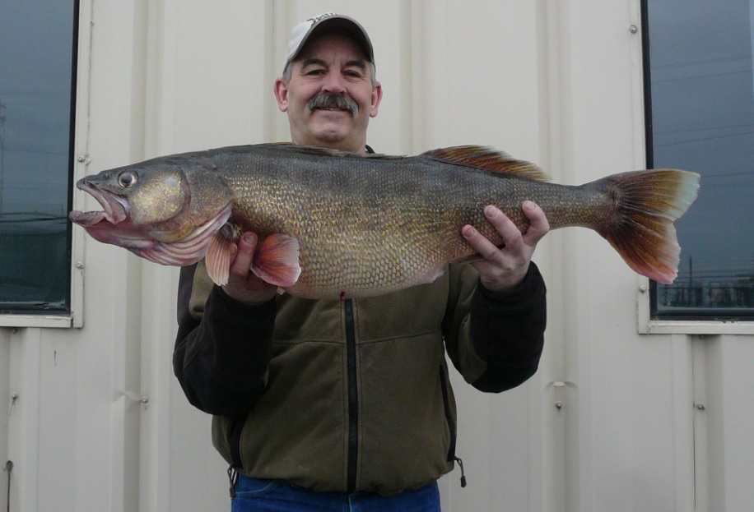

The record fish was caught by John Grubenhoff of Pasco, Washington in Lake Wallula, which is an impoundment on the main stem of the Columbia River near the Tri Cities (Pasco, Kennewick, Richland) area and the mouth of the Snake River. Anglers come to that area in the late winter and early spring with a realistic expectation of catching Walleye in the 12-16 pound range. Some people think the next world record will come from that area, but we have five pounds to go.

2015 was the 14th year that the Washington Department of Fish and Wildlife (WDFW) conducted its Fall Walleye Index Netting (FWIN) surveys on the top five Walleye waters in the state. The 2015 report is not complete at this time, but for all previous reports, please see the WDFW home page (wdfw.wa.gov) and in the upper right-hand corner type “FWIN” in the search window. This will take you to a publications page that has links to all the FWIN reports. The 2015 report should be online in February or March. These reports are targeted at anglers but are also useful for our managers. Our FWIN program adopted the Ontario protocol developed by George Morgan and Nigel Lester. It has been the lynchpin of our Walleye management program since 2002, allowing us to better asses our Walleye populations and assign what we feel are the most appropriate regulations for all of our key inland Walleye waters.

On a more somber Walleye note, in March of 2015, a WDFW crew gillnetted a dozen Walleye over a several day period in Lake Washington, a 28,000-acre lake between downtown Seattle and the suburbs of Renton, Bellevue, Kirkland and Kenmore. One of the fish captured in March of this year was a 13-pound, gravid female. Although Walleye are well established in a number of waters in the Columbia River basin in eastern Washington, (only 2½ hour’s drive from Seattle), and they have some of the densest and best Walleye populations for fishing in the country, WDFW strives to keep Walleye out the western half of the state to prevent negative interactions with native anadromous fish, i.e. salmon and steelhead. Lake Washington does have populations of non-native panfish and excellent fishing for Largemouth and Smallmouth Bass but Walleye represent another level of potential predation that we would prefer not to have on juvenile salmonids. Salmonids present in Lake Washington include: Sockeye Salmon, Kokanee, coastal cutthroat, Coho Salmon, federally listed steelhead and federally listed Fall Chinook Salmon.

The WDFW management goal for Walleye is to manage for and promote Walleye opportunities in waters where appropriate and where negative impacts to native species are negligible, but that is not everywhere they reside in Washington. In waters where negative impacts are more significant, or where the populations have expanded too much, we have lowered the minimum size limit and expanded the bag limit to encourage harvest, particularly of smaller fish. In the mid and upper sections of the main stem of the Columbia River and Snake River, where hundreds of millions of dollars have been spent on native salmon and steelhead restoration, daily bag limits and size limits on Walleye, bass and Channel Catfish have been removed. In the lower sections of the main stem of the Columbia River, where the waters are shared with the State of Oregon, both states’ Fish and Wildlife Commissions recently adopted sport rules removing size and daily bag limits for Walleye, bass and Channel Catfish. This is a conservation measure that has been widely supported in both states.

One of the more fun things our Warmwater Program has done in the last couple years has been to produce videos which promote a variety of fishing opportunities throughout the state in an attempt to get more people to target underexploited species and populations. We have two videos for “how to fish for Walleye”. All of our videos are posted on our searchable fishing opportunity database called “Fish Washington”. Anglers can search by species or geographic area. To find the videos, go to our Fish Washington landing page, at: <http://wdfw.wa.gov/fishing/washington/>, or just Google “Fish Washington” and then click the link near the bottom right that says “Find more fishing how-to videos here”. They are divided by species on the left-hand side in the blue highlighted section.

**Bruce Bolding**

Warmwater Fish Program Manager

Washington Department of Fish and Wildlife

600 Capital Way N

Olympia, Washington

98501-1091 USA

360-902-8417

[Bruce.Bolding@dfw.wa.gov](mailto:Bruce.Bolding@dfw.wa.gov)

**20.) West Virginia**

**Project Name: West Virginia Walleye Management Plan**

Name of Representative to Technical Committee: David Wellman

Contact Information: [David.I.Wellman@wv.gov](mailto:David.I.Wellman@wv.gov) (304) 825-6787

Date Submitted: 11 January 2016

The West Virginia Division of Natural Resources Wildlife Resources Section (DNR-WRS) manages walleye (*Sander vitreus*) in several rivers, small impoundments, and reservoirs. The walleye fishery in West Virginia is maintained by stocking efforts or natural reproduction. Historically, DNR-WRS focused on stocking as the primary management strategy and liberal angling regulations were in place. Genetic analysis identified a strain of walleye, the Eastern Highlands walleye, native to the Ohio River basin that is adapted to riverine conditions (White 2013; Zipfel 2006; Palmer 1999). Interest by DNR-WRS and the angling public concerning native walleye populations and the management of this river dwelling fish began in the early 2000’s. In addition, anglers expressed concerns over the generally small-size of walleye in some West Virginia reservoirs (Wichterman 2011). As a result of increased interest and concerns, DNR-WRS staff began a series of investigations focusing on providing information to aid in managing walleye.

Findings from DNR-WRS investigations supported the view that walleye populations are quite diverse in West Virginia with some water bodies able to support a trophy fishery, while other water bodies are better suited to support a “pan-size” fishery. Large rivers that are inhabited by Eastern Highlands walleye provide the best opportunity for a trophy fishery. Reservoirs inhabited by non-native Great Lakes walleye that adequately reproduce provide outstanding fishing opportunities for abundant, smaller size individuals.

As part of the plan development, DNR-WRS staff facilitated an on-line survey of interested anglers and the general public in the spring of 2014. The survey goal was to initiate information exchange and provide some guidance to DNR-WRS staff in the development of the plan. The on-line survey was completed by 234 individuals residing in 45 of the 55 West Virginia counties. Respondents ranged in age from 15 to over 65 years with the majority in the 31-50 age group. The majority selected walleye as their first or second choice on their fishing preference. Some of the findings included:

I. Seventy one percent (71%) of the respondents were somewhat satisfied, satisfied, or neutral when considering their view of their current West Virginia walleye fishing experience. Twenty nine percent (29%) were not satisfied with their walleye fishing experience.

II. Sixty percent (60%) harvested the walleye they caught and 50% of these individuals considered a 15-inch walleye a harvestable-size individual.

III. Diverse types of angling experiences were desired including catching a few large individuals (44%), catching and harvesting pan-size individuals (33%), and catching a trophy individual (24%).

IV. Ninety-one percent (91%) of the respondents would support some type of change in the angling regulations, but again expressed diverse views on what type of regulation strategy would be appropriate. These included strategies that would increase size (24%), increase harvest (9%), or increase both harvest and size (58%).

As a result of these investigations and the expressed interest by anglers, DNR-WRS staff initiated the development of a statewide walleye management plan. It is intended that this be a living plan*,* in that as more information is obtained, the strategies and actions will adapt. Implementation of angling regulations, walleye stocking, and investigation of walleye populations will be tools employed to manage walleye in West Virginia. In addition, DNR-WRS staff will continually solicit input from anglers to evaluate the plan’s effectiveness. Thus, thisplanshould not be considered the final approach to walleye management in West Virginia, but a work-in-progress.

Walleye characteristics, such as growth, abundance, reproduction, and genetics vary between the Ohio River, Kanawha River, and Monongahela River sub-basins; therefore a single regulation would not be effective. Beginning January 1, 2016, new regulations were initiated for each of the sub-basins. The goal of these regulations is to promote diverse walleye angling opportunities in a manner that will safeguard important walleye fishery resources. More restrictive regulations are proposed for water bodies that are being stocked with Eastern Highlands walleye or the potential for a trophy or large-size walleye fishery is evident (i.e. Kanawha River sub-basin). Less restrictive regulations are proposed for water bodies that are more suitable for anglers seeking higher numbers of pan-size walleye (i.e. Monongahela sub-basin). The following table list walleye West Virginia walleye regulations:



**David I. Wellman, Jr.**

**West Virginia Division of Natural Resources**

**District 1 Fisheries Biologist**

**PO Box 99**

**1110 Railroad Street**

**Farmington, West Virginia**

**26571 USA**

**phone:** [**304-825-6787**](tel:304-825-6787)

**21.) Wyoming (2 reports):**

**[I.]** In Wyoming, we actively manage for Walleye as an introduced sport fish in a number of waters as well as managing for our native Sauger population.  Walleye have been illegally introduced in a few waters the Wyoming Game and Fish Department manages for trout. In these waters predation impacts from walleye on the trout fisheries have been substantial.

Walleye were discovered in Buffalo Bill Reservoir in 2008.  Stable isotope analysis of introduced walleye determined these fish were introduced to Buffalo Bill Reservoir in 2002 and 2003 and were likely the result of an illegal introduction. Walleye have been reproducing in the reservoir and a recent study indicates rainbow and cutthroat trout comprise a substantial component of Walleye's diet and have the potential to impact those fisheries (Johnson and Johnson 2015).  Buffalo Bill Reservoir currently has no creel limit on walleye and requires all walleye caught to be killed immediately.  Additionally we consider Walleye in Buffalo Bill Reservoir a "nongame fish" which removes liability or wanton waste from anglers unwilling to consume the Walleye they catch and allows for other means of capture. A graduate student, Daniel Kaus, and his graduate advisor, Chrisopher Guy, at Montana Statue University are looking at the feasibility of suppressing Walleye in the Buffalo Bill Reservoir to conserve the wild trout fishery.

Johnson, B. M., and C. F. Johnson. 2015. Quantifying piscivory in buffalo Bill Reservoir: are the wild *Oncorhynchus* fisheries sustainable? Department of Fish, Wildlife, and Conservation Biology, Colorado State University Final Report. Wyoming Game and Fish Department, Cheyenne, Wyoming

**Jason Burckhardt**

Fisheries Biologist

Wyoming Game & Fish Dept.

2820 State Hwy 120

Cody, WY 82414

[(307) 527-7125](tel:%28307%29%20527-7125)

[jason.burckhardt@wyo.gov](mailto:jason.burckhardt@wyo.gov)

**[II.] Wyoming**

**Wyoming Update to the Walleye Technical Committee**

**North Central Division, American Fisheries Society**

**76th Midwest Fish and Wildlife Conference**, **Grand Rapids, MI**

**January 24-27th, 2016**

Compiled by Gordon Edwards and Paul Gerrity

Wyoming Game and Fish Department

Current Fishing Regulations

Wyoming has a statewide regulation allowing harvest of six Walleye per day or in possession, only two of which may be taken by spear gun. The statewide creel limit on Sauger is two fish per day or in possession. Sauger fishing is closed to nontribal members but no creel limit exists for tribal members on waters within the Wind River Reservation.

Special regulations pertaining to Walleye and Sauger include:

**I.** A nongame fish designation, must-kill, and unlimited harvest regulation for Walleye at Buffalo Bill Reservoir in Park County and in the entirety of the Green River, Little Snake River, Bear River, and Great Divide basins in response to illegal introductions.

**II.** A liberalized possession limit for Walleye (12), combined with Sauger (3), at Big Horn Reservoir in Big Horn County. Management of this robust fishery is shared with the State of Montana.

**III.** A restricted daily and possession limit of 3 Walleye at Deaver Reservior, a small impoundment in Park County.

**IV.** A liberalized daily and possession limit of 12 Walleye at Alcova Reservoir in Natrona County (no spear gun limitations), in attempt to balance the Walleye population with the trout fishery.

**V.** A 15 inch minimum length limit on Walleye at Glendo Reservoir in Platte County.

**VI.** Anglers are required to keep fish whole until they are done fishing for the day, such that species and numbers can be determined. A one-inch square of skin must remain upon fillets while afield or in transit to identify species.

**Walleye**

*Tournaments*

Interest in Walleye tournaments has increased during recent years in Wyoming, expanded to new waters, and grown into “big business.” Wyoming requires application for approval of fishing tournaments with at least 50 participants charging an entry fee. Primary waters where large (>50 participants), organized tournaments occur are Glendo, Boysen, and Keyhole reservoirs. The two major tournament groups are the Wyoming Walleye Stampede (http://www.wyomingWalleyestampede.com/b/) and the Wyoming Walleye Circuit (http://www.wyomingWalleye.com/). The growth of tournament activity has resulted in pressure upon the summer closure window when live-release tournaments are prohibited.

Live-release tournament formats are prohibited July 1st – September 15th, (June 15th – September 15th at Glendo) loosely based on anticipated surface water temperatures exceeding 65°F. Recent temperature monitoring indicated that the summer closure period may need expansion to reduce Walleye mortality. Tournament activities and water temperatures at major reservoirs will be monitored more closely over the next few years to evaluate the effectiveness of current rules.

*Casper Region*

Seminoe, Pathfinder, & Alcova reservoirs

A management balancing act continues between trout and Walleye fisheries at these reservoirs on the upper North Platte River in central Wyoming. All three reservoirs have regionally significant rainbow trout fisheries and are also known for producing large brown trout. Walleye first colonized Seminoe Reservoir, the furthest upstream, in the 1960s through introductions higher in the drainage. Over the next several decades, Walleye made their way downstream to Pathfinder and Alcova reservoirs. Walleye populations have boomed in these upper North Platte reservoirs over the last decade at the expense of the trout fisheries. Natural forage is inadequate for large populations of piscivores in these reservoirs so the stocked trout quickly became the prey of choice for growing Walleye. For example, angler catch rates of rainbow trout at Alcova Reservoir declined from 0.8 fish/hour prior to the Walleye boom to < 0.2 fish/hour post Walleye boom. A shift from stocking fingerling trout (approx. 3 inches) to fewer catchable trout (approx. 9 in) was required at great expense to sustain the trout fisheries in the face of increasing predation by Walleye, with little benefit, and no indications that rainbow trout catch rates will recover. Attempts to encourage Walleye harvest, through a liberalized creel limit at Alcova, for example, and promoting the Walleye fisheries has helped little. Creel surveys continue to show that the overwhelming majority of anglers target trout at these reservoirs.

Glendo Reservoir

Annual gillnetting CPUE indicated that Walleye abundance at Glendo was at a five-year low in 2015 (0.74 fish/hour) compared to the recent peak in 2011 (2.70 fish/hour). The wild Walleye population at Glendo is not supplemented with stocking and has suffered weak natural recruitment over the last three years. Declines in Walleye abundance are somewhat cyclic at Glendo but have been short-lived. A single strong age-class can arise from optimum late spring reservoir elevation and ample forage abundance to carry the fishery for several years.

Unfortunately, the harsh winter of 2013-14 resulted in a nearly complete die-off of Gizzard Shad at Glendo. This eliminated the primary forage base for Walleye and partially explains recently declining recruitment. Gizzard Shad overwinter at Glendo in high enough numbers during about nine out of ten winters to allow adequate repopulation and forage production the following spring. Wyoming Game and Fish collaborated with Nebraska Game and Parks in early 2015 to import adult Gizzard Shad from Nebraska to reestablish this population as well as at Keyhole Reservoir in northeast Wyoming. Juvenile shad appeared very abundant by late summer at both reservoirs. The reliance on this key forage species for high fishing quality in Wyoming waters underpins the importance of good relationships with our neighboring states. Glendo Reservoir also has the first and only length limit on Walleye in Wyoming – a 15 inch minimum length. The regulation was aimed at buffering sporadic recruitment and optimizing the yield of this major Walleye fishery. Modeling of population dynamics with Fishery Analysis and Simulation Tools and the synthesis of creel survey data to gage angler support indicated that the fishery may benefit from protecting age 1 to 3 Walleye. Population benefits have been unclear since implementing the regulation due to sporadic recruitment. However, it appears that the potential for Walleye to reach age-3 has increased which is a sign that the regulation may be working. Luckily, the majority of Glendo anglers have consistently supported the regulation (> 95%), which should afford ample time to confidently evaluate it.

*Laramie Region*

Wheatland Reservoir #1 (424 surface acres), located near the town of Wheatland, has a history of adult Gizzard Shad stocking, due to lack of overwinter survival. Stocking adult Gizzard Shad is a fisheries management tool used by the Wyoming Game and Fish Department for reservoirs with populations of warm and cool water game fish. Gizzard Shad stocking occurred annually from 1992 through 1999, but ceased from 2000 to 2004 and in 2004 reduced growth and condition were noted for Walleye. Based on this data it was determined to annually stock adult Gizzard Shad in the spring from 2005 through 2008 into Wheatland Reservoir #1. Trends in Walleye growth and condition following spring shad stocking were analyzed over this time-period using collected otoliths. The annual spring stocking of adult Gizzard Shad significantly increased Wr for most of the standardized length categories for Walleye when compared to years when Gizzard Shad were not stocked. Annual Walleye growth rates were variable from 1994 through 2008, regardless if adult Gizzard Shad were stocked in the spring. Adult Gizzard Shad have continued to be stocked annually since 2010 to maintain high Wr values for Walleye.

*Lander Region*

Boysen Reservoir is located in central Wyoming and is known as one of Wyoming’s top Walleye fisheries. It claims the current state record at 17.42 pounds, which was caught in 1991. The state creel/possession limit of 6 Walleyes applies to Boysen. It receives low to moderate fishing pressure, and annual mortalities ranged from 18% to 22% since 2009. The fishery is maintained by erratic natural recruitment; however, strong year-classes occur often enough to provide a good fishery. Fisheries managers are also reluctant to stock Walleyes to reduce the threat of hybridization with a genetically-pure Sauger population. Temporal differences in spawning likely prevents hybridization between the two species, as Walleyes spawn in mid-to late-April and Saugers spawn in late-May to early-June. The near-future of Walleye fishing at Boysen Reservoir is bright, as strong 2011, 2014, and 2015 year-classes currently exist in the reservoir.

**Sauger**

*Bighorn River drainage*

The Bighorn River drainage currently contains thriving fisheries in both the Bighorn River and Big Horn Reservoir. Consistently high reservoir pool elevations create abundant nursery habitat that provide the necessary conditions for natural recruitment. The Big Horn Reservoir fishery is monitored through annual gill netting, and the Bighorn River fishery is monitored through electrofishing. Saugers are also tagged throughout the drainage to obtain survival and exploitation estimates. From 2008 - 2014, annual survival probability of Saugers was 78% (95% CI = 72% - 83%), and exploitation ranged from 10% to 30%. The quality of Sauger angling in the Bighorn River and Big Horn Lake increases when turbidity is lower during summer and fall (June - Oct), and when ice conditions are better (i.e., safe) during the first half of the ice fishing season (Nov - Jan). With this in mind, annual variability in exploitation likely reflects the frequency of these factors being met on a given year.

A recent threat to the Bighorn River Sauger population arose in 2014 when saugeye were observed for the first time. An evaluation of hybridization threat is ongoing.

*Wind River drainage*

Annual electrofishing population estimates are used to monitor Saugers within lotic portions of the drainage, and annual gill netting is used to monitor Saugers within Boysen Reservoir. Population estimates showed a 73% decline in age-1 and older Saugers from 2002 to 2011, and gill net catch rate declined by 96% from 2001 to 2011. Sauger harvest is low throughout the drainage. Recent annual mortality estimates ranged from 10% to 15%. The decline in the Sauger population was caused by a lack of natural recruitment. Low-water years throughout the early 2000s combined with irrigation-caused dewatering dried up known nursery areas within the Wind River and Boysen Reservoir throughout the decade-long period. Low-water levels may have also increased water temperatures to levels unsuitable for natural reproduction.

A supplemental stocking operation commenced in 2013 and will continue through 2017 to supplement natural recruitment. The operation includes collecting wild adults, spawning them streamside, hatching the eggs and raising fish in a hatchery system, and stocking fingerlings and advance-fingerlings back into Wind River-drainage waters. From 2013 to 2015 approximately 477,000 fingerling or advance-fingerling Saugers were stocked throughout the drainage.

Sauger numbers have increased within the drainage, particularly within the lotic portion of the drainage. Estimated number of Saugers within the river system in 2015 was 90% of 2002 numbers, but Boysen Reservoir catch rate was only 9% of the mean 1993 - 2002 catch rate. Good water years in 2011, 2014, and 2015 provided good spawning conditions and abundant nursery habitat and resulted in strong year-classes. The 2014 and 2015 year-classes were also supplemented by stocked fish. Evaluation of the contribution of stocked fish to the 2013 – 2015 year classes is ongoing.

*North Platte River Drainage*

Sauger were extirpated from the North Platte River near Casper during the latter half of the 20th century. Interest has grown in reestablishing them to this reach of river to provide sport fishing opportunities where little currently exists. Discussions are ongoing to acquire Sauger fry from an appropriate source to stock in the river below the town of Glenrock. The preferred source would be within the lower North Platte River system to protect genetic integrity within the drainage and to employ potential local adaptations of a nearby stock.

**Mark Smith**

Assistant Fisheries Management Coordinator

Wyoming Game and Fish Department

office [307-777-4560](tel:307-777-4560)

cell [307-220-7590](tel:307-220-7590)

[mark.smith2@wyo.gov](mailto:mark.smith2@wyo.gov)

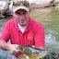

**22.) Indiana**

**Indiana AFS Walleye Technical Committee Report**

Submitted: January 17, 2016

Statewide stocking in 2014: 870,180 fingerlings and 27,846,800 fry

Statewide stocking in 2015: 1,074,947 fingerlings (1-2”), 94,440 advanced fingerlings (6.5-9.5”), and 22,832,192 fry

**Monroe Reservoir Walleye tagging study**

Sandra Clark-Kolaks, Southern Fisheries Research Biologist, Indiana Department of Natural Resources

A total of 157 walleye were tagged in Lake Monroe in spring 2015 with spaghetti tags in the spring of this year. Tagged walleye ranged from 9.4 inches to 25.5 inches. Fish were tagged with a yellow tag in the back that has 4-digit number. Some fish are tagged with a single tag while others have two tags. Since tagging a total of 12 fish have been reported caught on rod and reel. Of those 12, 4 have been released and 8 have been harvested. Further, of those 12 reported caught, 3 have been caught in the tailwaters, having traveled through the dam and into the spillway below Lake Monroe. If all tags still remain attached to fish that were tagged in the spring of this year, approximately 143 tags remain in the system. At all public boat ramps there are boxes containing envelopes which ask for some information of a fisher if he or she is to catch a tagged walleye. All tags are located at the base of the dorsal fin and upon catching a tagged walleye we ask that the fisher fills out an envelope (located in marked boxes at all public boat ramps) leaving the tag inside. Information from this project will help us estimate the percentage of walleye harvested each year so that we may assess our stocking efforts and regulations.

**Jason Doll**

Department of Biology

Ball State University

Muncie, Indiana

47306 USA

765-729-6199

[jcdoll@bsu.edu](mailto:jcdoll@bsu.edu)

**23.) Nebraska**

**State of Nebraska WTC Update, 2016**

January 19, 2016

NGPC biologist Tony Barada reported that intensive efforts to produce and stock advanced (8-9”) walleyes and saugeyes in southeast Nebraska is ongoing. Seven waterbodies were stocked with advanced saugeye and 14 were stocked with advanced walleye during the fall of 2015. Similar stockings will take place during 2016. A regulation change back to the statewide minimum 15” was also implemented at the beginning of 2016. Fall gill netting efforts will assist in the evaluation of the advanced fish stockings.

Brett Miller (MS student – UNK) in collaboration with NGPC is currently creating a standardized sampling protocol for age-0 white bass and age-0 walleye comparing three gear types across three months over two years on Harlan County Reservoir, Nebraska. CPUE values will be calculated for each gear type to determine which gear type is most appropriate. Diet analysis will also be conducted on age-0 white bass to determine food habits.

Matthew Perrion (MS student – UNK) in collaboration with NGPC is focusing on early life-stages of white bass and walleye in Lake McConaughy, Nebraska. He will describe the seasonal diets of juvenile white bass and walleye (age-0 and age-1) and evaluate walleye (using OTC) and white bass (using otolith microchemistry) stock contribution.

BJ Schall (MS student – UNK) in collaboration with NGPC will be assessing the population dynamics of the sportfish community in Lake McConaughy, Nebraska. Additionally, he will be examining the seasonal spatial distribution of fishes throughout the reservoir.

**Casey W. Schoenebeck**

 Associate Professor

Department of Biology

 University of Nebraska at Kearney

Kearney, Nebraska

68849-1140 USA

[308.865.8545](tel:308.865.8545)

[schoenebeccw@unk.edu](mailto:schoenebeccw@unk.edu)

**24.)** **Wisconsin**

**2016 Walleye Technical Committee Winter Meeting Wisconsin Report**

**submitted January 21, 2016**

1. **Wisconsin Walleye Initiative (WWI)**

This program has been extended and funded in the state budget until July of 2019. This will make about 12 million dollars of general state funds available over the next two years for hatchery improvements and stocking programs. Money from this fund is being used to make infrastructure improvements to several state fish hatcheries. At the Art Oehmcke state fish hatchery located in Woodruff , three new lined rearing ponds are under construction, an expanded water filtration and UV system are being installed, and the cold water supply improved.

The state walleye team is focused on developing a plan to evaluate the success of fall fingerling walleye stocked as part of the WWI. The team’s decision was to study the effect of various stocking densities, and measuring success by two main management goals, listed in order of priority:

1. (Re)-establishing natural walleye reproduction
2. Establish and maintain fishable walleye populations

In each year, all lakes receiving fall fingerling walleye will be assigned to one of four treatment groups: 5, 10, 15 or 20 fall fingerlings per acre. A subset of 72 “sentinel lakes” was randomly chosen to be monitored annually through the duration of the project. The adaptive management component is intended to commence after three stocking cycles, with elimination of stocking from waters with no return and hopefully identifying an optimum stocking rate (or optimums for specific classes of lakes).

At this point, monitoring is confined to observations of age-1 returns in spring or fall after stocking. These data are a marginally useful glimpse into fingerling survival, as catch rates of age-1 walleye are highly variable and the relationship of age-1 catch rate to actual abundance of those fish is unknown. Evaluation of returns to the adult fishery will begin in 2017 on a limited scale (products of the pilot year 2013 stocking) and in earnest in 2018.

1. **Hatchery Production**

Due to the funding of the WWI program a significant number of large walleye fingerlings ( > 6”) were again produced in our state and private hatchery system in 2015. The state hatcheries also produced a significant number of small fingerling (1.2 to 2” ) walleye.

State Small State Large Private Large Total Large

2013 416,506 21,965 438,477

2014 1,373,650 506,891 212,779 719,670

2015 1,503,074 527,570 349,795 877,365

2016 972,826 (proposed) 802,040 (proposed)

1. **Regulation Changes**

The state natural resources board granted WDNR flexibility to consider alternatives to reductions in walleye bag limits in the ceded territory. With this authority the department set the daily bag limit on all ceded territory waters at three per lake effective on May 2, 2015. The daily statewide bag limit of 5 fish would remain in effect. This rule would prevent the need to make annual adjustments to daily bag limits and size limits for walleye in response to tribal declarations and harvest in the Wisconsin Ceded Territory. Instead, all lakes, rivers, and streams in the Ceded Territory would have a daily bag limit of 3 walleye (walleye, sauger, or hybrids) with varying size limits. The 3-fish daily bag limit and size limits would be applied to specific waters to prevent a total harvest (tribal and non-tribal) of more than 35% of the adult walleye population in those waters, which preserves a sustainable walleye fishery.

Under this rule, a “Ceded Territory walleye management zone” is being created in addition to a 3-fish daily bag limit. Walleye in most waters in the Ceded Territory would have a minimum size limit of 15 inches, except walleye between 20 and 24 inches may not be kept and only 1 walleye larger than 24 inches may be kept. Unless a different regulation was requested by the local fisheries biologist to ensure better management of the walleye population in specific water, lakes would have size limits based on the following table:

|  |  |
| --- | --- |
| **If the current regulation is: 🡪** | **Then it will become this under the rule:** |
| 15" minimum size, 5 fish daily bag limit (general statewide walleye regulations) | 15" minimum size, 20-24” protected slot, and 1 fish may be >24", 3 fish daily bag limit |
| No minimum size, 5 fish daily bag limit | No minimum size, but only 1 fish may be >14", 3 fish daily bag limit |
| No minimum size, but only 1 fish may be >14", 3 or 5 fish daily bag limit | No minimum size, but only 1 fish may be >14", 3 fish daily bag limit |
| No minimum size, 14-18” protected slot, and 1 fish may be >18", 3 or 5 fish daily bag limit | No minimum size, 14-18” protected slot, and 1 fish may be >18", 3 fish daily bag limit |
| 18" minimum size, 3 fish daily bag limit | 18" minimum size, 3 fish daily bag limit |
| 28" minimum size, 1 fish daily bag limit | 28" minimum size, 1 fish daily bag limit |

The changes noted above affect the 30 counties that are completely or partially within the Ceded Territory. The walleye bag limit was also reduced to 3 fish per day on Wisconsin-Michigan boundary waters within the Ceded Territory, but retains the 15-inch minimum size limit to match the Michigan size limit. No changes are made to Wisconsin-Minnesota boundary waters. The regulation changes follow the Ceded Territory boundary line, not county boundary lines.

This same rule change created a catch-and-release only walleye fishery in the Minocqua - Tomahawk chain of lakes in Oneida County. Out of mutual concern for the walleye population in this mixed-fishery chain of Ceded Territory lakes, representatives of the Lac Du Flambeau Chippewa Tribe, the Headwaters Basin Chapter of Walleyes for Tomorrow, the Wisconsin DNR, and the Great Lakes Indian Fish and Wildlife Commission have collaboratively developed a plan for a cooperative rehabilitation project. It seeks to restore healthy, self-sustaining walleye populations with a density of at least three adult fish per acre in Minocqua and Kawaguesaga lakes, and to improve the age diversity and abundance of walleye in Tomahawk Lake. All parties mentioned have agreed to not harvest walleye in the Minocqua chain of lakes for a period of five years - until March 31, 2020 - at which point limited harvest would be permitted.

While the overall effect of these changes is expected to be neutral or slightly negative in terms of angler walleye harvest across the Ceded Territory, the changes were very well received. The desire for consistency in regulations was immense.

**Statewide Trolling Rule**

Trolling with three lines is currently allowed in most counties statewide. However, seventeen of the state’s 72 counties were covered by regulations that prohibit trolling or allow it only on select waters.

As of July 1, 2015 trolling is now allowed in these counties with the following restrictions:

* Only one line can be trolled per angler with a limit of two lines per boat.
* You can cast and retrieve up to two additional lines per angler.
* There is a 3 year sunset clause on this regulation.

1. **Staff Issues**

There was a realignment of the state natural resources agency to line authority by program. As a result of this change fisheries was removed from the water program and placed in the new division of Fisheries, Wildlife and Parks.

**Fisheries Bureau Director**

Ron Bruch who was appointed to this position in early 2014, retired in early 2015. Justine Hasz was hired as the new fisheries bureau director in the fall of 2015. Justine worked her way up through the states fisheries program and most recently held the position of fisheries services section chief.

**Fisheries Deputy Director**

This newly created position was filled in November of last year by Todd Kalish. Todd came to us from Minnesota and had worked in Michigan before that. His duties will include supervising the four district fisheries supervisors and he will report directly to the bureau director.

**District Fisheries Supervisors**

There currently are two district supervisor openings in the state. Scot Stewart (southern district) and Randy Schumacher (east district) both retired last fall. Recruitment will open soon and hopefully these positions will be filled in the next few months.

There are plans to fill several biologist and technician positions around the state once these higher level positions are filled.

Application information for all state seasonal and permanent positions can be found on the Wisconsin state employment site [www.wisc-jobs](http://www.wisc-jobs).

1. **Walleye Research**

**Wisconsin DNR Research**

1. The ten year, Sherman Lake 50% annual walleye exploitation study will conclude on March 31, 2016. Following ten years of study, an annual rate of 50% walleye exploitation frequently dropped annual adult abundances below desired levels of 3/acre, significantly reduced the size structure of the walleye population and decreased age at maturity, and the sex ratio of the population was skewed strongly towards males. Interestingly, no change in age 0 or age 1 recruitment was observed during the study period; however, Sherman Lake walleye recruitment is consistently strong and the walleye recruitment of this lake is not indicative of other Ceded Territory walleye lakes.
2. A 25-30 year study to test for fish production responses (including walleye as a focal study species) to whole-lake additions of coarse woody habitat was initiated in 2015. Pre-manipulation sampling of the fish community and aquatic ecosystem characteristics will be monitored during 2015-2018, followed by three phases of tree drops and post-manipulation monitoring.
3. Walleye production was assessed on Escanaba Lake during 1965-2009. Walleye production in Escanaba Lake was high relative to other Ceded Territory of Wisconsin lakes and a sustainable exploitation rate over this time series was estimated at 22%. This article was published by Rypel et al. in the Canadian Journal of Fisheries and Aquatic Sciences. Ongoing research is assessing walleye production in all Ceded Territory walleye lakes and this information will be used to inform a statistical catch at age model to estimate sustainable walleye exploitation using production under various minimum length and bag limits.
4. Gretchen Hansen completed her work on a mixed-effects model to better predict Ceded Territory walleye abundances when population estimates are outdated or unavailable. This manuscript was published recently in the North American Journal of Fisheries Management (see below).
5. WDNR, the University of Wisconsin-Madison Center for Limnology, and UW-Stevens Point have partnered in a USGS funded project to examine the impacts of climate change on the resilience of sport fish species.

The goal of this project is to investigate the resilience of sport fisheries to climate change using the example of walleye and black bass fisheries of the Western Great Lakes region, centering on Wisconsin. In recent years, walleye stocks have decreased while black bass stocks have increased in some lakes of the region. The perceived changes have generated a great deal of interest from managers and stakeholders. Many of the explanations for the walleye decline and bass increase focus on suspected changes in the conditions that influence the two species and their interactions. These include the greater harvest rates of walleye versus black bass; decreases in nutrient inputs and increases in macrophyte cover favoring black bass over walleye; warmer temperatures which are more favorable for black bass than walleye. Other explanations that are not necessarily exclusive to walleye and black bass interactions include regional drought, shoreline modifications, species invasions and other factors which alter habitat; and further the idea that walleye declines may be occurring in lakes that did not historically support the species but that sustain walleye through stocking. An overarching goal of the project is to evaluate management strategies that are resilient to the great uncertainty about the drivers of walleye decline and the potential effects of future unknown changes in climate.

1. WDNR BAWLeRS (Bass and Walleye Lakes with Experimental Regulations and Stocking (BaWLERS)) study. Numerous northern Wisconsin lakes have witnessed concurrent increases in Largemouth Bass and decreases in Walleye over the past 20 years. A substantial amount of debate over the mechanisms driving these trends has occurred and various management actions intended to reverse these trends have been proposed. In 2009, approximately 26 lakes were included in a coordinated effort to reverse these trends utilizing readily available management techniques (harvest regulations and stocking).

In 2009, the working group that developed the treatment suite decided to use all of the readily available management tools on all the lakes to maximize the chances of decreasing largemouth bass abundance while at the same time increasing adult and juvenile walleye abundance. The management tools or treatments included removal of the minimum length limit on black bass, an increase of the minimum length limit on walleye to 18”, a reduction in the walleye bag limit to 3, and stocking of large fingerling walleye in the fall at 10/acre in every other year. This treatment suite was developed under the general hypothesis that increased largemouth bass abundance was inhibiting walleye recruitment through direct predation; thus reducing largemouth bass population size, stocking fall fingerling walleye to bypass first-summer predation, and increasing protection for adult and particularly spawning walleye could all interact to increase walleye abundance. While this approach does not enable identification of which treatment component is responsible for any observed changes, it does maximize the likelihood of success in terms of increased walleye abundance. Furthermore, if the approach is ultimately unsuccessful, management will learn that reversing these shifts in sport fish community dominance may not be possible using traditional fisheries management tools. However, little attention was paid to the evaluation portion of this effort.

In January of 2014, WDNR Fisheries Management and Science Services staff held a workshop with faculty from UW-Madison’s Center for Limnology to develop a plan to maximize the capability of learning from this large-scale experiment. The workshop focused on identifying objectives, selecting reference lakes as well as “legitimate“ treatment lakes, and developing a monitoring plan. This document lays out the plan developed in the workshop to evaluate the effectiveness of this suite of management tools (hereafter treatment suite) for improving walleye populations.

Goals

• Restore walleye natural reproduction

• Increase adult walleye population abundance in lakes experiencing declines

Objectives

• Walleye YOY catch rates of 10/mile (average across 4 years) in 50% of lakes within 8 years

• Largemouth bass catch rates less than 5/mile (average across 4 years) in 50% of lakes within 8 years

**University of Wisconsin Stevens Point Research**

* + - 1. Michael F. Vaskeis working on a project to develop a genetic broodstock management plan for Wisconsin’s walleye propagation program.The overall goal of this project is to develop a genetic broodstock management plan which includes standardized collection techniques, including both numbers and sex ratios for the broodfish, spawning and rearing techniques, and fish distribution protocols. In the process, several specific research objectives will be addressed including (1) comparing the genetic diversity within Wisconsin’s feral walleye broodstock with genetic diversity levels in other wild, naturally recruiting, Wisconsin walleye populations; and (2) determine if levels of inbreeding, effective population size, and the probability of spawning related individuals differed between fish collected with different gears (electrofishing and fyke netting) and varying levels of sampling effort. Preliminary results show that genetic diversity within the propagation program is comparable with levels found in other populations in Wisconsin. Both Teal Lake and Tomahawk Lake exceeded the minimum threshold values (MTV; Sloss and Turnquist 2014), and had an inbreeding level considerably lower than the northern WI and respective management unit averages. Results from the comparison of genetic diversity between gears (fyke nets vs. electrofishing) showed comparable levels of genetic diversity between gears; however electrofishing appears to capture more genetic diversity than fyke nets in both broodstock lakes. Along with comparing different gear, varying levels of sampling effort were compared to determine the effects on genetic diversity metrics. Preliminary results from these effort comparisons suggest that effort should be increased to obtain larger numbers of broodfish to increase genetic diversity within the progeny. Results also suggest that broodfish should be sampled over a larger portion of the spawn to capture more genetic diversity within the populations.
      2. Hadley Boehm (now with MN DNR) completed the first phase of the UWSP project exploring potential walleye recruitment bottlenecks in northern WI lakes and she determined that at least one bottleneck is occurring at or before the larval stage. She also determined that we can monitor age-0 walleye abundance during the first year of life using a progression of larval tows, small-mesh gill nets, and fall electrofishing. Based on these findings UWSP will expand their sampling to more lakes to verify the initial findings and determine what factors may be contributing to lack of fry production. UWSP also plan to inject OTC-marked fry into a lake or two with a history of failed fry production to see if they survive until fall (i.e., is the fry stage the only bottleneck). Jason Gostiaux is the new graduate student on this project which is funded by Wisconsin DNR.
      3. UWSP is working with Wisconsin and Michigan DNR biologists to determine: 1) the contribution of different spawning locations to the Green Bay walleye fishery and 2) if biological characteristics (e.g., growth, age structure, and fecundity) vary among fish spawning at these different locations. They have submitted pre-proposals to Great Lakes funding sources to develop an acoustic array that would look at the fishery contribution question. In 2015, we collected 50 adult walleyes from the Fox, Peshtigo, Menominee, and Oconto rivers (four primary WI tributaries where walleye spawning occurs) to obtain otoliths and ovaries. UWSP are in the process of comparing biological characteristics among walleyes spawning in each river and will present these results at the 2016 Wisconsin AFS meeting.
      4. UWSP has been conducting net-pen and hatchery trials to determine tag retention and mortality associated with implanting age-0 walleyes with 12-mm PITs.  The lowest mortality (≤ 5%) and have highest retention occurred when inserting tag between the pelvic fins. UWSP will conduct another round of trials in 2016.
      5. In collaboration with Wisconsin DNR, the UWSP initiated a long-term assessment of walleyes in the Stevens Point Flowage. The hope is to generate annual estimates of abundance and survival. This data will be used to determine if this method has merit as a means for monitoring walleye populations in inland lakes.

1. **Wisconsin walleye-related publications, 2015:**
2. Hansen, G.J., Hennessy, J.M., Cichosz, T.A. and Hewett, S.W., 2015. Improved Models for Predicting Walleye Abundance and Setting Safe Harvest Quotas in Northern Wisconsin Lakes. *North American Journal of Fisheries Management*, *35*(6), pp.1263-1277.

The model described in the above publication will be used to set harvest quotas for high-efficiency capture methods (i.e. spearing and netting) in the Wisconsin Ceded Territory in 2016. The models represents a sophisticated advancement beyond the linear regression model previously used to set harvest quotas, and should be both more biologically appropriate within lakes for which walleye population data are available and respond more to trends both within individual lake populations and across the Ceded Territory.

1. Hansen, G.J., Carpenter, S.R., Gaeta, J.W., Hennessy, J.M. and Vander Zanden, M.J., 2015. Predicting walleye recruitment as a tool for prioritizing management actions. *Canadian Journal of Fisheries and Aquatic Sciences*.
2. Rypel, A.L., Goto, D., Sass, G.G. and Vander Zanden, M.J., 2015. Production rates of walleye and their relationship to exploitation in Escanaba Lake, Wisconsin, 1965–2009. *Canadian Journal of Fisheries and Aquatic Sciences*.
3. HANSEN, J.F., SASS, G.G., GAETA, J.W., HANSEN, G.A., ISERMANN, D.A., LYONS, J. and VANDER ZANDEN, M.J., 2015. Largemouth Bass Management in Wisconsin: Intraspecific and Interspecific Implications of Abundance Increases. In *American Fisheries Society Symposium* (Vol. 82, pp. 193-206).
4. Koenigs, R.P., Bruch, R.M., Stelzer, R.S. and Kamke, K.K., 2015. Validation of otolith ages for walleye (Sander vitreus) in the Winnebago System. *Fisheries Research*, *167*, pp.13-21.

**Presentations:**

Hansen, G., 2015, August. Resilience of Optimal Thermal Habitat to Climate Change in Wisconsin Lakes. In *145th Annual Meeting of the American Fisheries Society*. AFS.

Gaeta, J.W., 2015, August. Muskellunge (Esox masquinongy) Predation on Walleye (Sander vitreus) Affects Population Size Structure and Harvest: A Modeling Approach. In *145th Annual Meeting of the American Fisheries Society*. AFS.

**Steve Gilbert**

Fisheries Biologist -Vilas County

Bureau of Fisheries Management

Wisconsin Department of Natural Resources

8770 Highway J,

Woodruff, Wisconsin

54568 USA

715-356-5211 ext 229

[stephen.gilbert@wisconsin.gov](mailto:stephen.gilbert@wisconsin.gov)

**25.) Pennsylvania**

submitted January 22, 2016

Inland Walleye populations within Pennsylvania are receiving greater assessment attention, especially where stocking is taking place as guided by a recently prepared “[Plan for Management of Pennsylvania’s Inland Walleye Fisheries” (2011)](http://fishandboat.com/pafish/walleye/walleye_plan.pdf).

<http://fishandboat.com/pafish/walleye/walleye_plan.pdf>

The initial focus of the plan is to insure that cultured Walleye are contributing to angler catch by measuring contributions of cultured and marked Walleye to assessment catch and/or assessing change in assessment catch rate following experimental cessation of stocking.  To insure cost effective use of cultured fish, in those waters where stocking is contributing to the assessment catch; the Plan requires that assessment catch rates meet minimum catch rate benchmarks for Walleye stocking to continue.  Initial assessments have focused upon reservoirs and lakes where Walleye fingerling stocking is taking place and where Walleye assessment catch rates are low.  To date assessments have led to most “low catch rate waters” being removed from the Walleye stocking program.  With respect to experimental stocking cessation, beginning in 2008, stocking cessation occurred on most all Pennsylvania river sections previously stocked with fry and/or fingerling.  Walleye assessment catch rate measurement continues following cessation and mimics pre-cessation sampling.  On many river sections changes in assessment catch rate benchmarks were met, with Walleye population maintenance relying solely upon natural recruitment.  On several river sections and some stream sections, changes in assessment catch rates did not meet plan benchmarks whereas, during stocking periods, had met benchmarks.  Changes in catch rate on these river and stream sections were sufficient to cause fishery managers to request resumption of Walleye stocking.  Plan guidelines require rigorous assessment of marked stocked Walleye where resumption has taken place, with those assessments ongoing.  A summary of river Walleye stocking cessation sampling results through 2014 are available in: a [Walleye Plan Update 2014](http://fishandboat.com/pafish/walleye/walleye_plan_update_2014.pdf).

<http://fishandboat.com/pafish/walleye/walleye_plan_update_2014.pdf>

**Robert M. Lorantas**

Warmwater Unit Leader

Pennsylvania Fish and Boat Commission

450 Robinson Lane

Bellefonte, PA  16823

Ph [814-359-5168](tel:814-359-5168) Fx [814-359-5153](tel:814-359-5153)

rlorantas@pa.gov